O splendour of God’s glory bright Hymnal 1982 no. 5 Melody: Puer nobis nascitur L.M.
British spelling
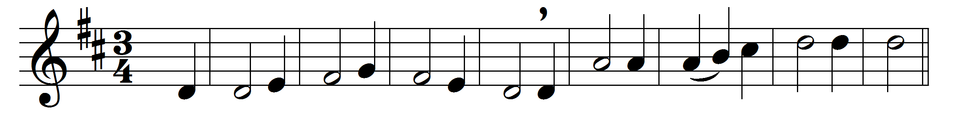
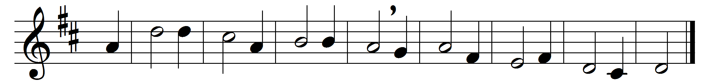

O splendour of God’s glory bright,
O thou that bringest light from light,
O Light of Light, light’s living spring,
O Day, all days illumining,

O thou true Sun of heavenly love,
pour down thy radiance from above:
the Spirit’s sanctifying beam
upon our earthly senses stream.

With prayer the Father we implore:
O Father, glorious evermore,
we plead with thee for grace and power
to conquer in temptation’s hour,

to guide whate’er we nobly do,
with love all envy to subdue,
to give us grace our wrongs to bear,
to make ill fortune turn to fair.

All laud to God the Father be;
all praise, eternal Son, to thee;
all glory to the Spirit raise
in equal and unending praise.

Words: Ambrose of Milan (340-397), translated by Robert Seymour Bridges (1844-1930)
Music: Melody from Trier MS, 15th century, adapted by Michael Praetorius (1571-1621), harmony by George Ratcliffe Woodward (1848-1934)

