Teach me, my God and King Hymnal 1982 no. 592 Melody: Carlisle S.M.
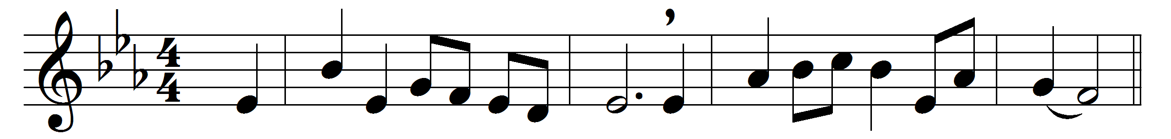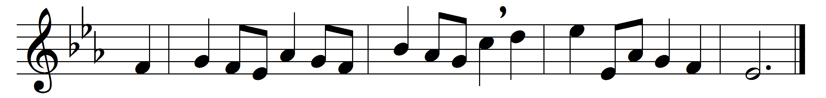

Teach me, my God and King,
in all things thee to see,
and what I do in anything,
to do it as for thee.

All may of thee partake;
nothing can be so mean,
which with this tincture, ‘for thy sake,’
will not grow bright and clean.

A servant with this clause
makes drudgery divine:
who sweeps a room, as for thy laws,
makes that and th’ action fine.

This is the famous stone
that turneth all to gold;
for that which God doth touch and own
cannot for less be told.

Words: George Herbert (1593-1633)
Music: Charles Lockhart (1745-1815)

