Lo, he comes with clouds descending Hymnal 1982 no. 58 Melody: St. Thomas 8 7. 8 7. D.
Words from AMNS
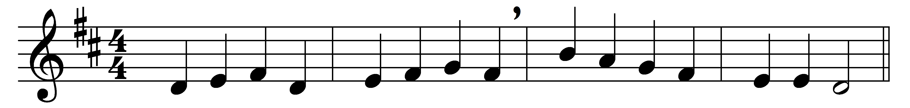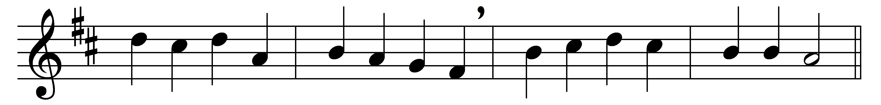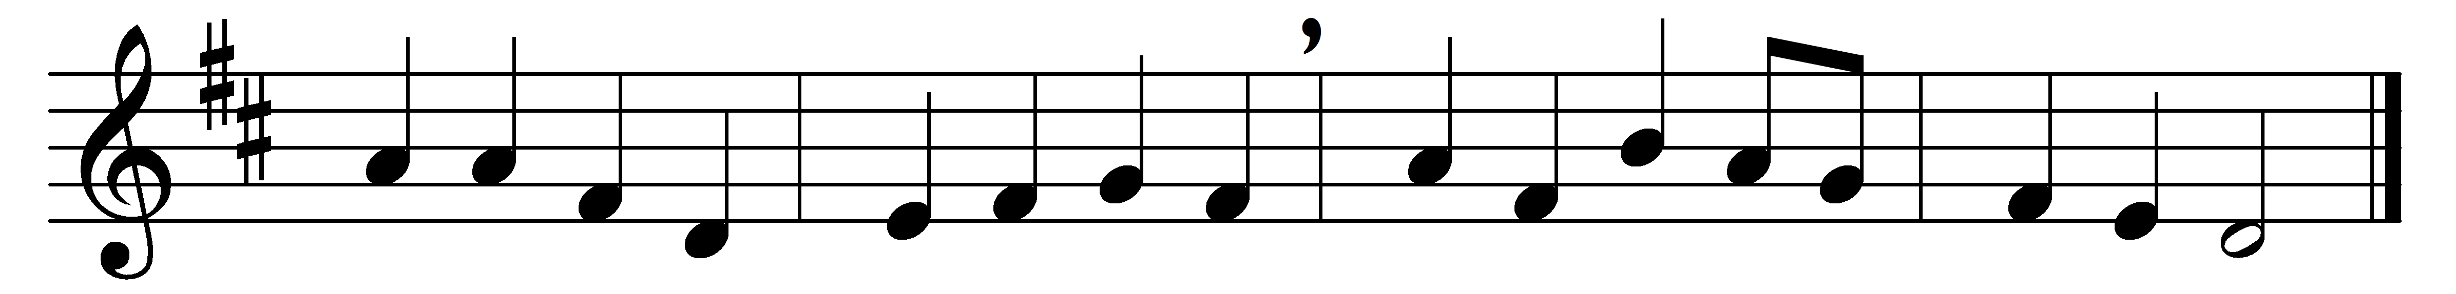
Lo, he comes with clouds descending,
once for favoured sinners slain;
thousand thousand saints attending
swell the triumph of his train:
Alleluia!
Christ appears on earth to reign.

Every eye shall now behold him
robed in dreadful majesty;
those who set at naught and sold him,
pierced and nailed him to the Tree,
deeply wailing,
shall the true Messiah see.

Those dear tokens of his passion
still his dazzling body bears,
cause of endless exultation
to his ransomed worshippers:
with what rapture
gaze we on those glorious scars!

Yea, Amen, let all adore thee,
high on thine eternal throne;
Saviour, take the power and glory,
claim the kingdom for thine own:
Alleluia!
thou shalt reign, and thou alone.

Words: Charles Wesley (1707-1788) and John Cennick (1718-1755)
Music: Traditional melody (18th century)

