Lo! he comes, with clouds descending Hymnal 1982 no. 58 Melody: St. Thomas 8 7. 8 7. D.

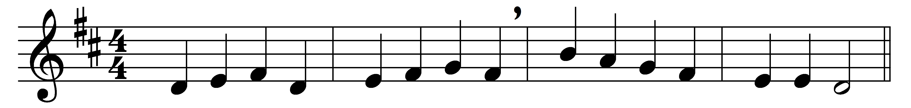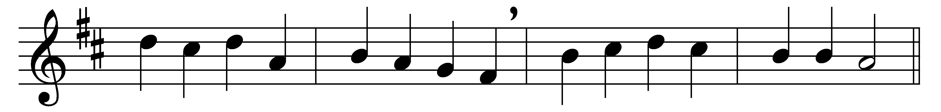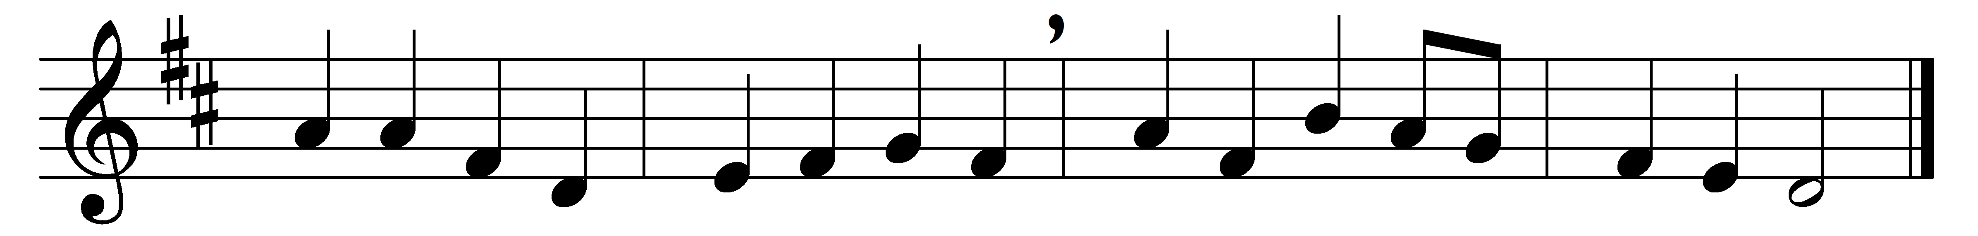

Lo! he comes, with clouds descending,
once for our salvation slain;
thousand thousand saints attending
swell the triumph of his train:
Alleluia! Alleluia!
Christ the Lord returns to reign.

Every eye shall now behold him,
robed in dreadful majesty;
those who set at nought and sold him,
pierced, and nailed him to the tree,
deeply wailing, deeply wailing,
shall the true Messiah see.

Those dear tokens of his passion
still his dazzling body bears,
cause of endless exultation
to his ransomed worshipers;
with what rapture, with what rapture
gaze we on those glorious scars!

Yea, amen! let all adore thee,
high on thine eternal throne;
Savior, take the power and glory;
claim the kingdom for thine own:
Alleluia! Alleluia!
Thou shalt reign, and thou alone.

Words: Charles Wesley (1707-1788)
Music: Traditional melody (18th century)

