O God of love, O King of peace Hymnal 1982 no. 578 Melody: Eltham L.M.
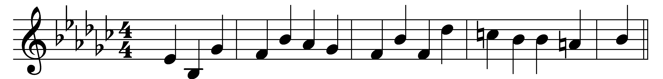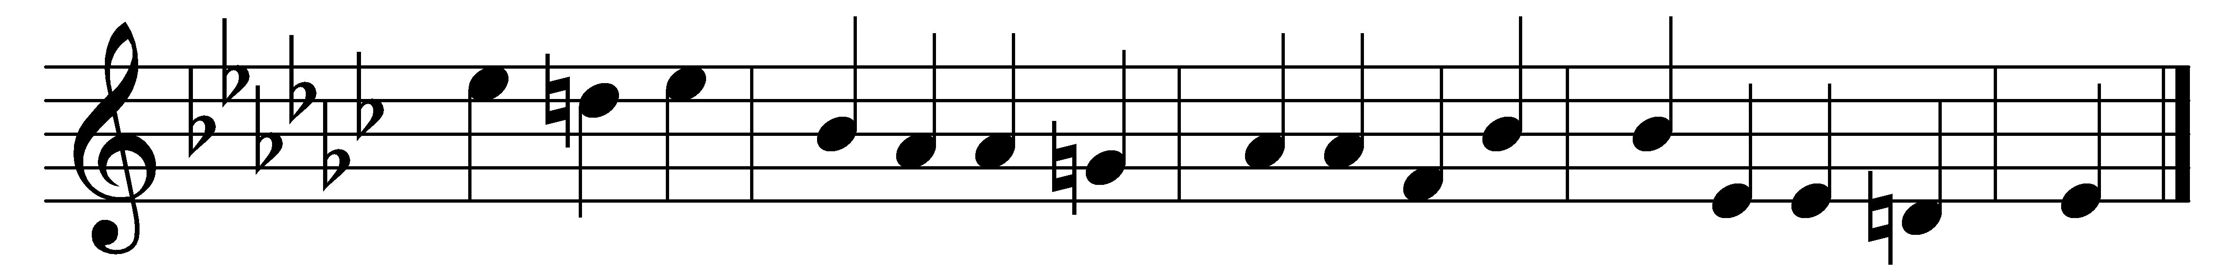

O God of love, O King of peace,
make wars throughout the world to cease;
the wrath of nations now restrain,
give peace, O God, give peace again!

Remember, Lord, thy works of old,
the wonders that thy people told;
remember not our sin’s dark stain,
give peace, O God, give peace again!

Whom shall we trust but thee, O Lord?
Where rest but on thy faithful word?
None ever called on thee in vain,
give peace, O God, give peace again!

Words: Henry Williams Baker (1821-1877)
Music: Melody by Nathaniel Gawthorn (18th century), harmony by Samuel Sebastian Wesley (1810-1876)

