God the Omnipotent! Hymnal 1982 no. 569 Melody: Russia 11 10. 11 9.
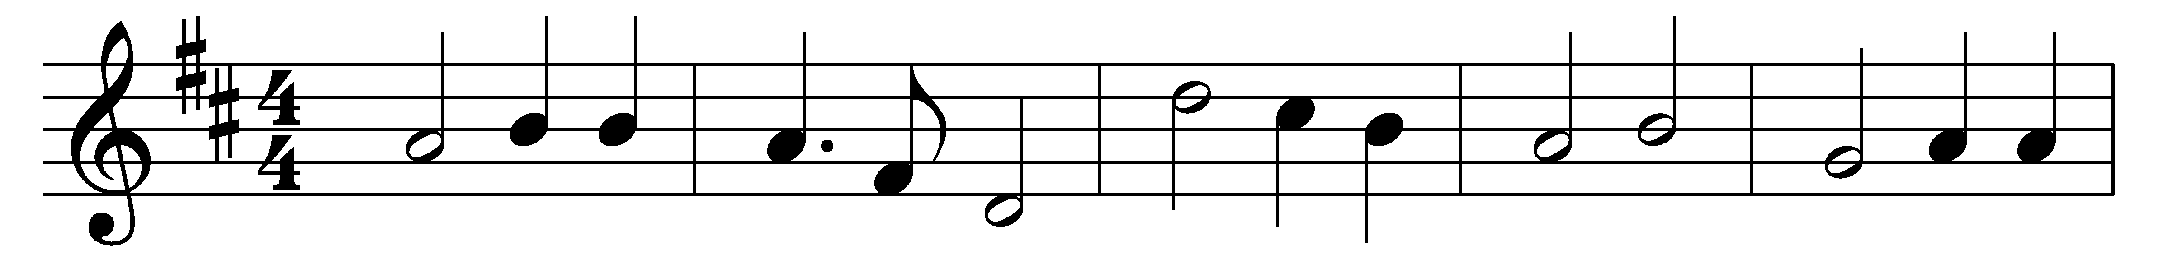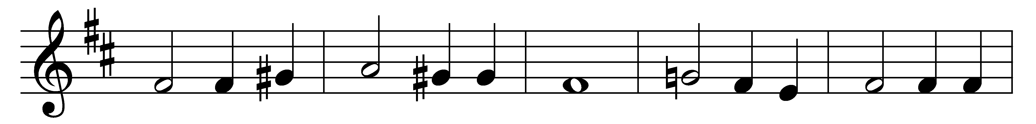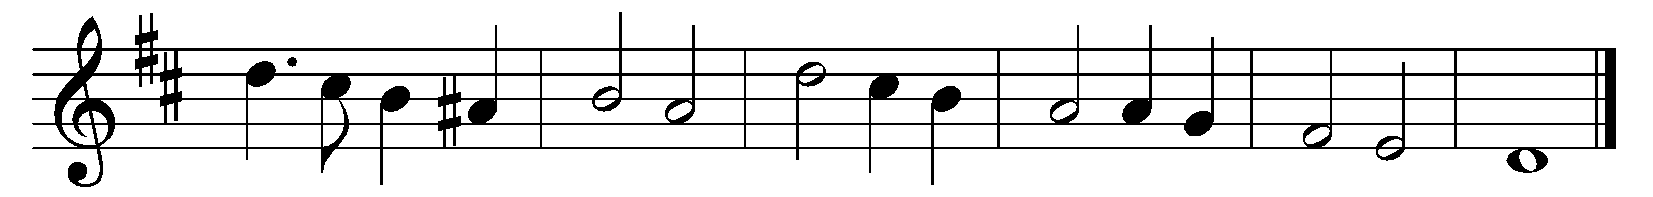

God the Omnipotent! King, who ordainest
thunder thy clarion, the lightning thy sword;
show forth thy pity on high where thou reignest:
give to us peace in our time, O Lord.

God the All-merciful! earth hath forsaken
thy ways all holy, and slighted thy word;
bid not thy wrath in its terrors awaken:
give to us peace in our time, O Lord.

God, the All-righteous One! earth hath defied thee;
yet to eternity standeth thy word,
falsehood and wrong shall not tarry beside thee:
give to us peace in our time, O Lord.

God the All-provident! earth by thy chastening
yet shall to freedom and truth be restored;
through the thick darkness thy kingdom is hastening:
thou wilt give peace in thy time, O Lord.

Words: vv. 1 and 2: Henry Fothergill Chorley (1808-1872); vv. 3 and 4: John Ellerton (1826-1893)
Music: Alexis Lvov (1799-1870)

