Go forward, Christian soldier Hymnal 1982 no. 563 Melody: Lancashire 7 6. 7 6. D.
British spelling
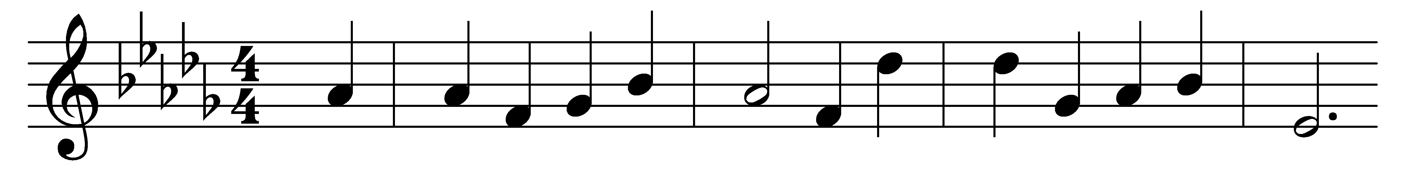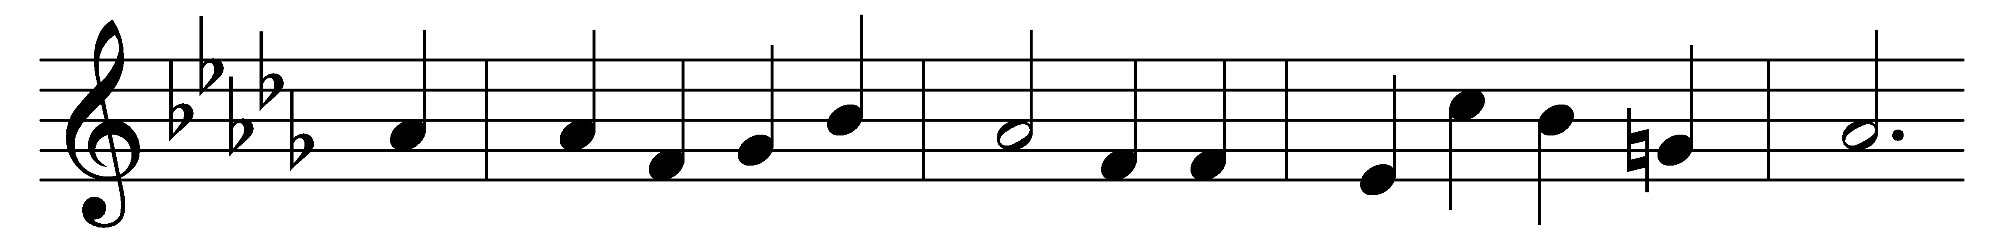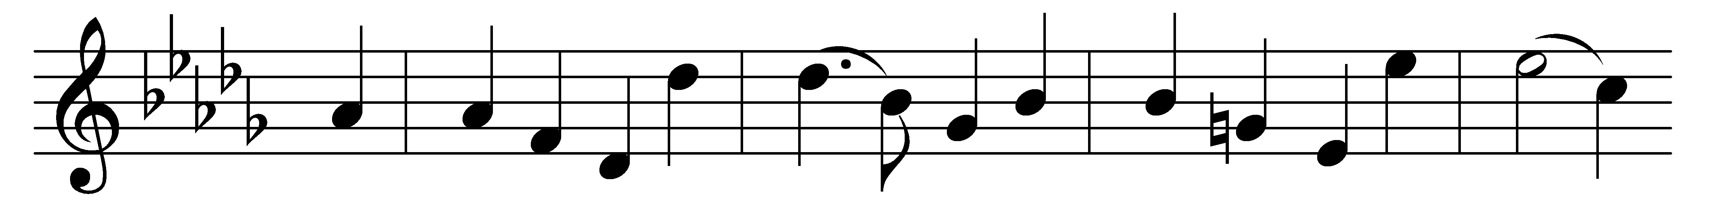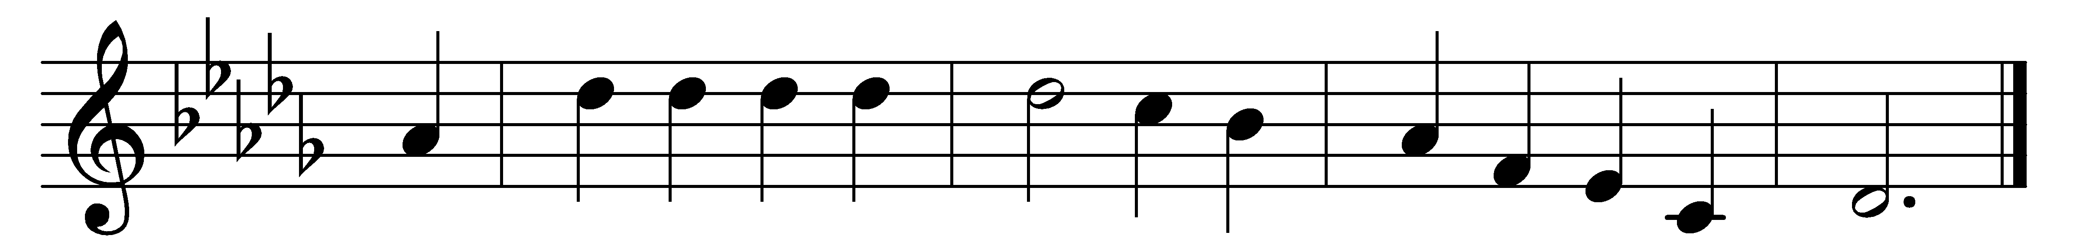

Go forward, Christian soldier,
beneath his banner true:
the Lord himself, thy Leader,
shall all thy foes subdue.
His love foretells thy trials;
he knows thine hourly need;
he can with bread of heaven
thy fainting spirit feed.

Go forward, Christian soldier,
fear not the secret foe;
far more o’er thee are watching
than human eyes can know:
trust only Christ, thy Captain;
cease not to watch and pray;
heed not the treacherous voices
that lure thy soul astray.

Go forward, Christian soldier,
nor dream of peaceful rest,
till Satan’s host is vanquished
and heaven is all possessed;
till Christ himself shall call thee
to lay thine armour by,
and wear in endless glory
the crown of victory.

Go forward, Christian soldier,
fear not the gathering night:
the Lord has been thy shelter;
the Lord will be thy light.
When morn his face revealeth
thy dangers all are past:
O pray that faith and virtue
may keep thee to the last!

Words: Laurence Tuttiett (1825-1895)
Music: Henry Thomas Smart (1813-1879)

