Lead us, heavenly Father, lead us Hymnal 1982 no. 559 Melody: Dulce carmen 8 7. 8 7. 8 7.
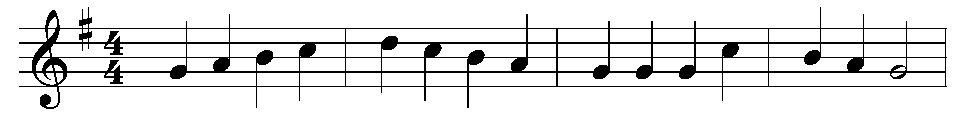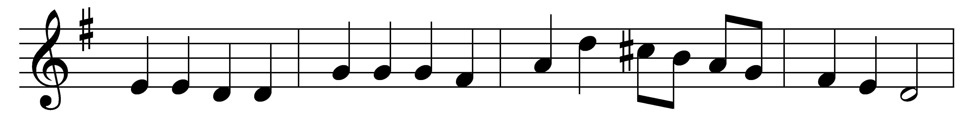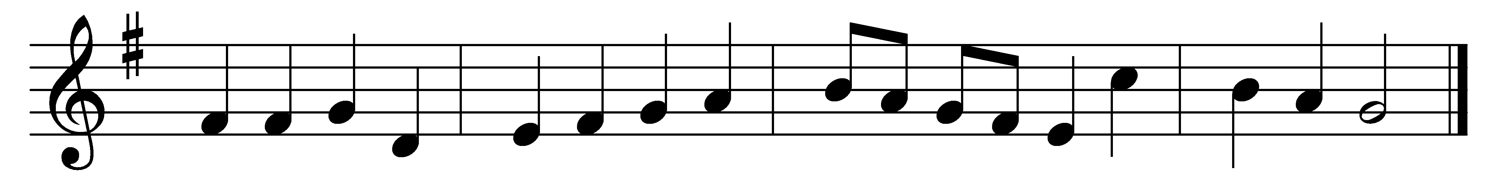

Lead us, heavenly Father, lead us
o’er the world’s tempestuous sea;
guard us, guide us, keep us, feed us,
for we have no help but thee,
yet possessing every blessing,
if our God our Father be.

Savior, breathe forgiveness o’er us;
all our weakness thou dost know;
thou didst tread this earth before us;
thou didst feel its keenest woe;
yet unfearing, persevering,
to thy passion thou didst go.

Spirit of our God, descending,
fill our hearts with heavenly joy;
love with every passion blending
pleasure that can never cloy;
thus provided, pardoned, guided,
nothing can our peace destroy.

Words: James Edmeston (1791-1867)
Music: Melody from An Essay on the Church Plain Chant, 1782, adapted in the Collection of Motetts or Antiphons, c. 1840, harmonised by William Henry Monk (1823-1889)

