Fight the good fight with all thy might Hymnal 1982 no. 552 Melody: Pentecost L.M.
Words from AMNS
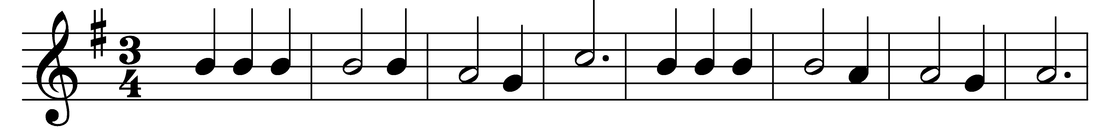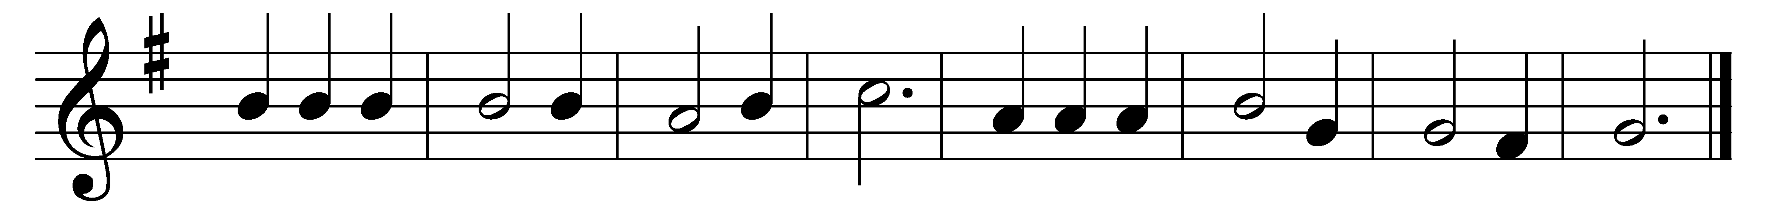

Fight the good fight with all thy might;
Christ is thy strength, and Christ thy right;
lay hold on life, and it shall be
thy joy and crown eternally.

Run the straight race through God’s good grace,
lift up thine eyes, and seek his face;
life with its way before us lies;
Christ is the path, and Christ the prize.

Cast care aside, lean on thy guide;
his boundless mercy will provide;
trust, and thy trusting soul shall prove
Christ is its life, and Christ its love.

Faint not nor fear, his arms are near;
he changeth not, and thou art dear;
only believe, and thou shalt see
that Christ is all in all to thee.

Words: John Samuel Bewley Monsell (1811-1875)
Music: William Boyd (1847-1928)

