Lo! what a cloud of witnesses Hymnal 1982 no. 545 Melody: St Fulbert C.M.
British spelling

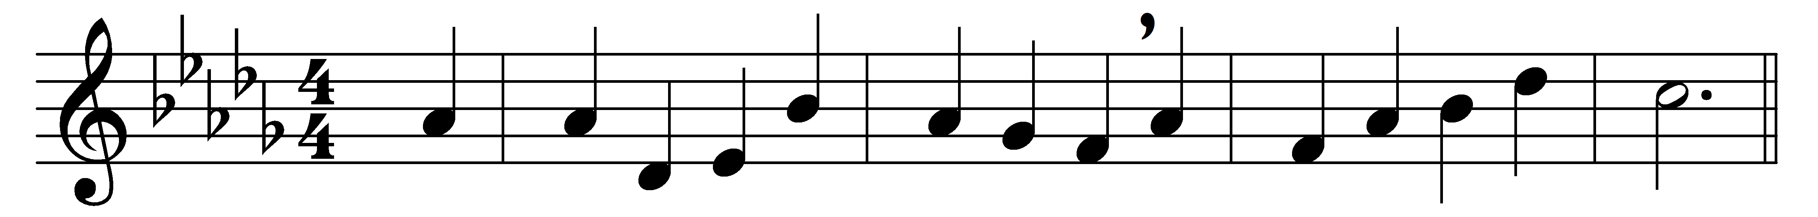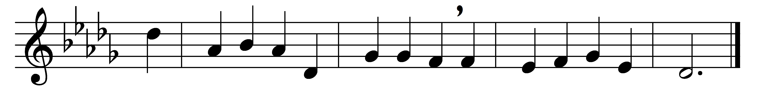

Lo! what a cloud of witnesses
encompass us around!
They, once like us with suffering tried,
are now with glory crowned.

Let us, with zeal like theirs inspired,
strive in the Christian race;
and, freed from every weight of sin,
their holy footsteps trace.

Behold a Witness nobler still,
who trod affliction’s path:
Jesus, the author, finisher,
rewarder of our faith.

He, for the joy before him set,
and moved by pitying love,
endured the cross, despised the shame,
and now he reigns above.

Thither, forgetting things behind,
press we to God’s right hand;
there, with the Saviour and his saints,
triumphantly to stand.

Words: Translations and Paraphrases, 1745
Music: Henry John Gauntlett (1805-1876)

