Come, labor on Hymnal 1982 no. 541 Melody: Ora Labora 4. 10 10. 10 4.

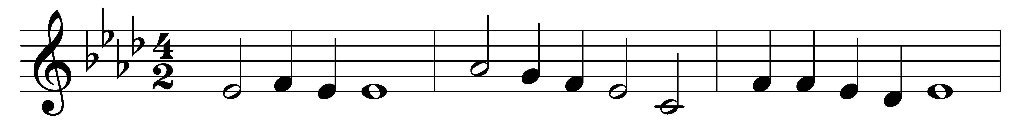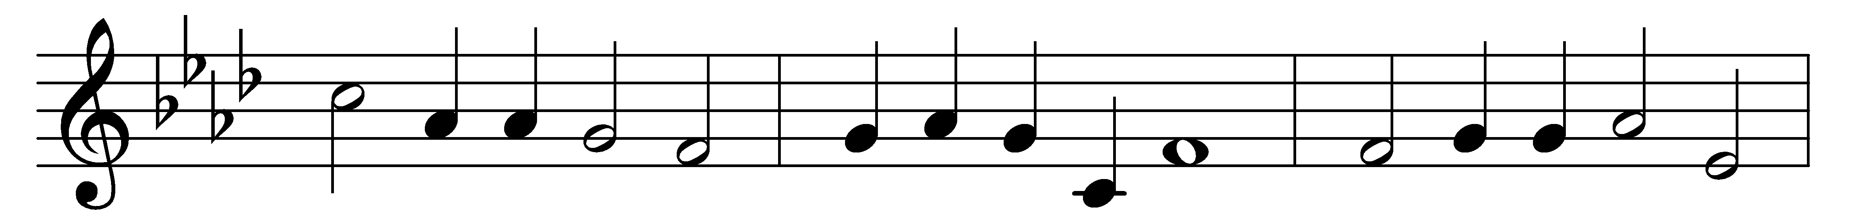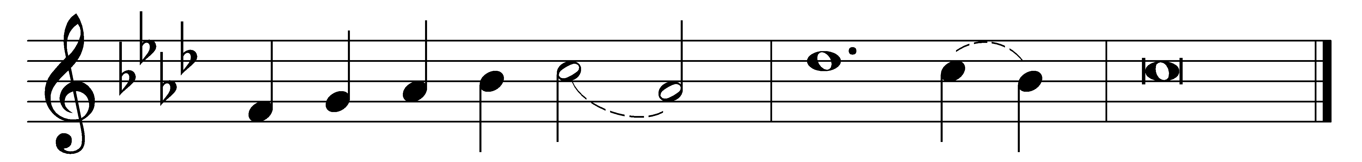

Come, labor on.
Who dares stand idle on the harvest plain,
while all around us waves the golden grain?
And to each servant does the Master say,
‘Go work today.’

Come, labor on.
The enemy is watching night and day,
to sow the tares, to snatch the seed away;
while we in sleep our duty have forgot,
he slumbered not.

Come, labor on.
Away with gloomy doubts and faithless fear!
No arm so weak but may do service here:
by feeblest agents may our God fulfill
his righteous will.

Come, labor on.
Claim the high calling angels cannot share –
to young and old the Gospel gladness bear:
redeem the time; its hours too swiftly fly.
The night draws nigh.

Come, labor on.
No time for rest, till glows the western sky,
till the long shadows o’er our pathway lie,
and a glad sound comes with the setting sun,
‘Servants, well done.’

Words: Jane Laurie Borthwick (1813-1897)
Music: Thomas Tertius Noble (1867-1953)

