Once he came in blessing Hymnal 1982 no. 53 Melody: Gottes Sohn ist kommen 6 6. 6 6. 6 6.
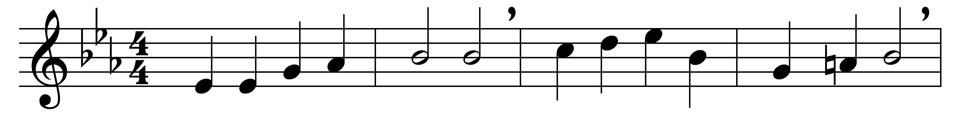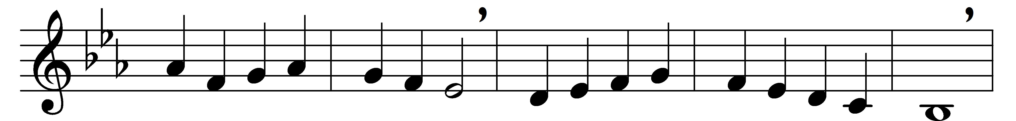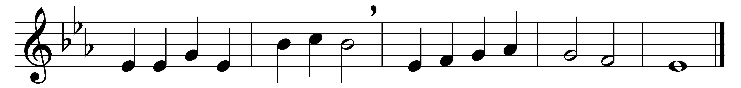

Once he came in blessing,
all our ills redressing;
came in likeness lowly,
Son of God most holy;
bore the cross to save us,
hope and freedom gave us.

Still he comes within us,
still his voice would win us
from the sins that hurt us,
would to Truth convert us:
not in torment hold us,
but in love enfold us.

Thus, if thou canst name him,
not ashamed to claim him,
but wilt trust him boldly
nor dost love him coldly,
he will then receive thee,
heal thee, and forgive thee.

One who thus endureth
bright reward secureth.
Come, then, O Lord Jesus,
from our sins release us;
let us here confess thee
till in heaven we bless thee.

Words: Jan Roh (c.1485-1547), translated by Catherine Winkworth (1827-1878)
Music: Melody by Michael Weisse (d. 1534)

