God of mercy, God of grace Hymnal 1982 no. 538 Melody: Ratisbon 7 7. 7 7. 7 7.
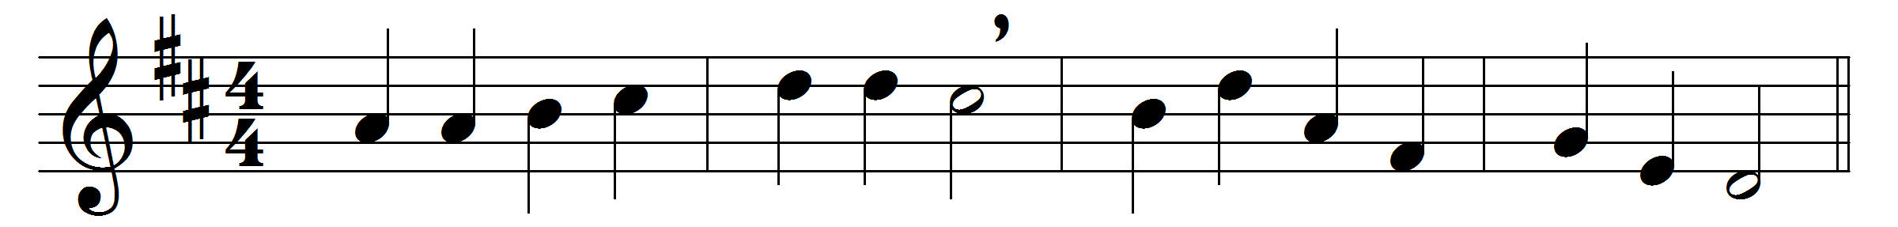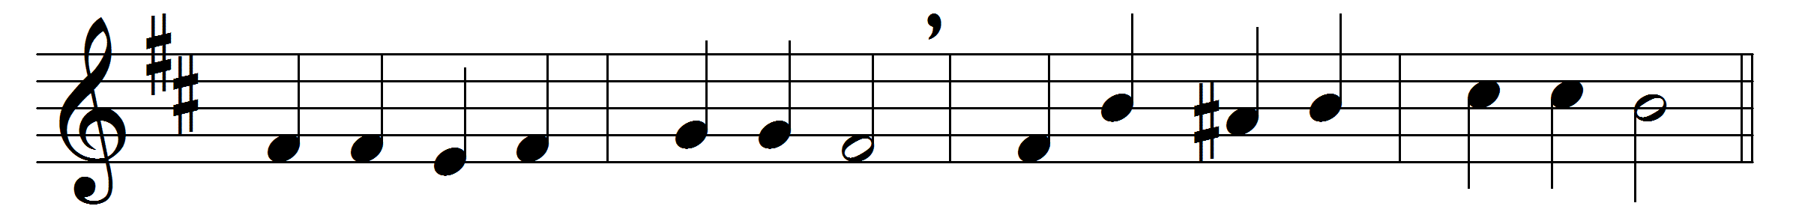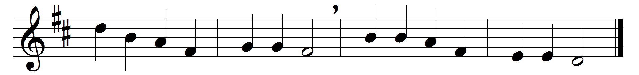

God of mercy, God of grace,
show the brightness of thy face.
Shine upon us, Savior, shine,
fill thy Church with light divine,
and thy saving health extend
unto earth’s remotest end.

Let thy people praise thee, Lord;
be by all that live adored.
Let the nations shout and sing
glory to their Savior King;
let all be, below, above,
one in joy, and light, and love.

Words: Henry Francis Lyte (1793-1847)
Music: Melody from Werner’s Choralbuch (Leipzig, 1815)

