Singing songs of expectation Hymnal 1982 no. 527 Melody: Ton-y-Botel 8 7. 8 7. D.

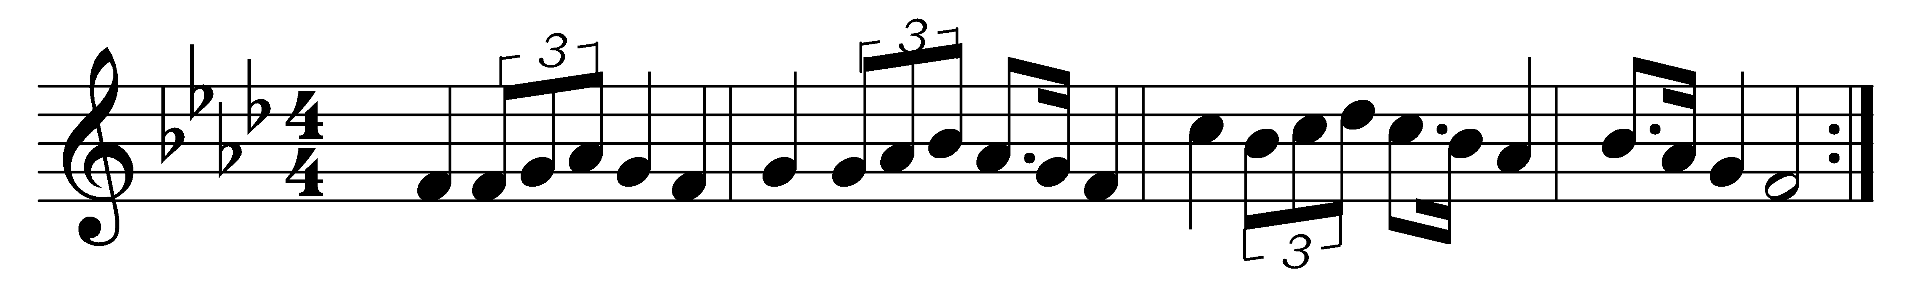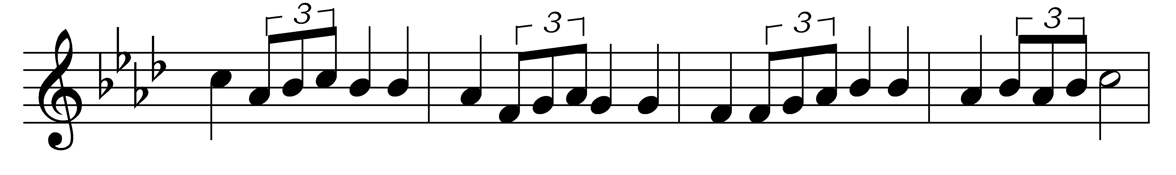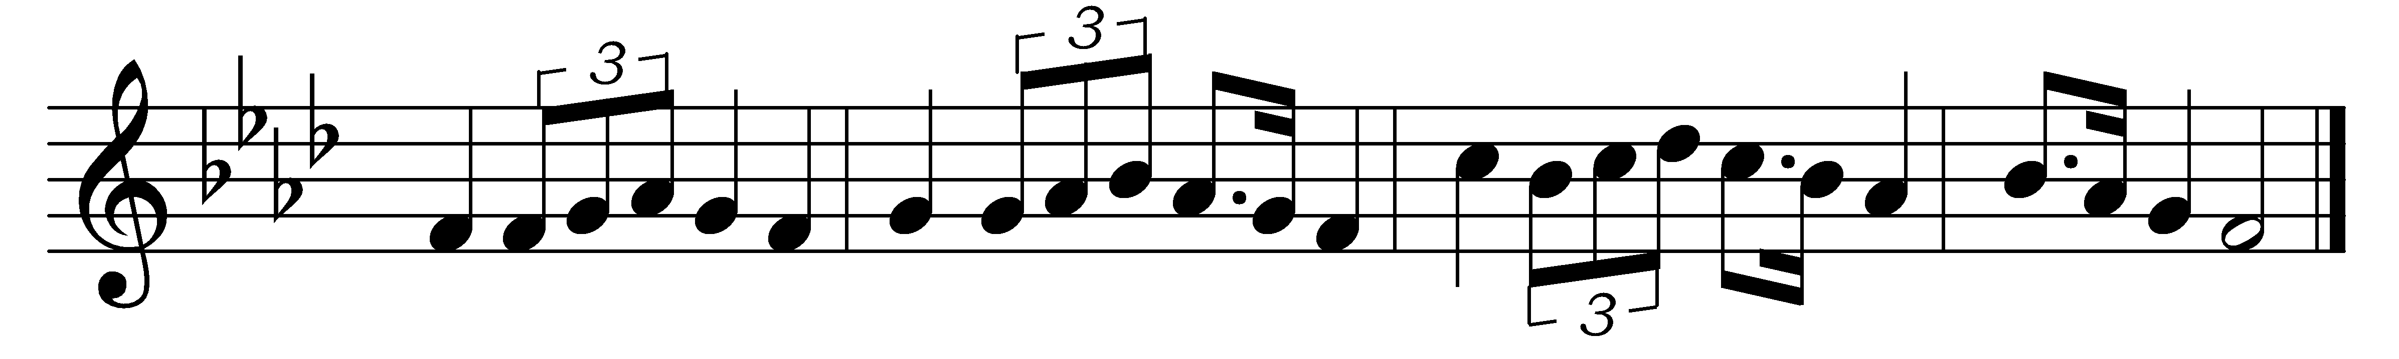

Singing songs of expectation,
onward goes the pilgrim band,
through the night of doubt and sorrow,
marching to the promised land.
Clear before us through the darkness
gleams and burns the guiding light:
trusting God we march together
stepping fearless through the night.

One the light of God’s own presence,
o’er his ransomed people shed,
chasing far the gloom and terror,
brightening all the path we tread:
one the object of our journey,
one the faith which never tires,
one the earnest looking forward,
one the hope our God inspires.

One the strain the lips of thousands
lift as from the heart of one;
one the conflict, one the peril,
one the march in God begun:
one the gladness of rejoicing
on the far eternal shore,
where the one almighty Father
reigns in love for evermore.

Words: Bernard Severin Ingemann (1789-1862), translated by Sabine Baring-Gould (1834-1924)
Music: Thomas John Williams (1869-1944)

