Let saints on earth in concert sing Hymnal 1982 no. 526 Melody: Dundee C.M.
Words from AMNS
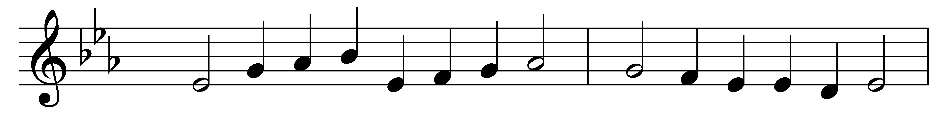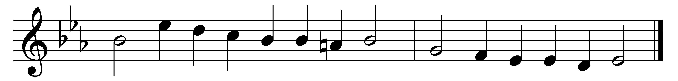

Let saints on earth in concert sing
with those whose work is done;
for all the servants of our King
in heaven and earth are one.

One family, we dwell in him,
one Church, above, beneath;
though now divided by the stream,
the narrow stream of death.

One army of the living God,
to his command we bow:
part of the host have crossed the flood,
and part are crossing now.

E’en now to their eternal home
there pass some spirits blest;
while others to the margin come,
waiting their call to rest.

Jesu, be thou our constant guide;
then, when the word is given,
bid Jordan’s narrow stream divide,
and bring us safe to heaven.

Words: Charles Wesley (1707-1788) and others
Music: Melody from Psalms (Edinburgh, 1615), harmony by Thomas Ravenscroft (1592?-1635?)

