Blessed city, heavenly Salem Hymnal 1982 no. 519 Melody: Urbs beata Jerusalem 8 7. 8 7. 8 7.

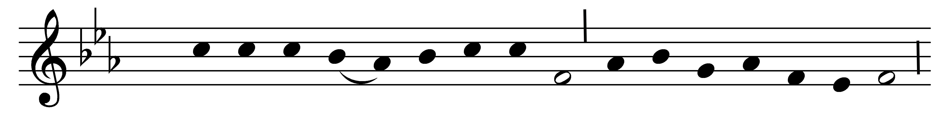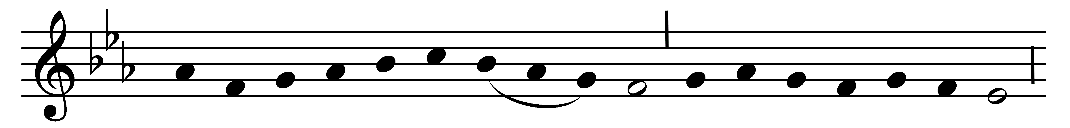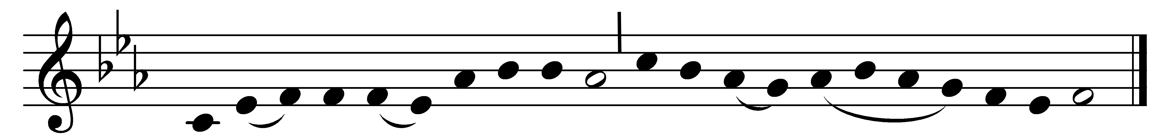

Blessèd city, heavenly Salem,
vision dear of peace and love,
who of living stones art builded
in the height of heaven above,
and, with angel hosts encircled,
as a bride dost earthward move;

from celestial realms descending,
bridal glory round thee shed,
meet for him whose love espoused thee,
to thy Lord shalt thou be led;
all thy streets and all thy bulwarks
of pure gold are fashionèd.

Bright thy gates of pearl are shining;
they are open evermore;
and by virtue of his merits
thither faithful souls do soar,
who, for Christ’s dear Name, in this world
pain and tribulation bore.

Many a blow and biting sculpture
polished well those stones elect,
in their places now compacted
by the heavenly Architect,
who therewith hath willed for ever
that his palace should be decked.

Laud and honor to the Father,
laud and honor to the Son,
laud and honor to the Spirit,
ever Three, and ever One,
consubstantial, co-eternal,
while unending ages run.

Words: Latin, c. 7th century, translation after John Mason Neale (1818-1866)
Music: Mode ii, 13th century, Nevers MS

