Christ is made the sure foundation Hymnal 1982 no. 518 Melody: Regent Square 8 7. 8 7. 8 7.
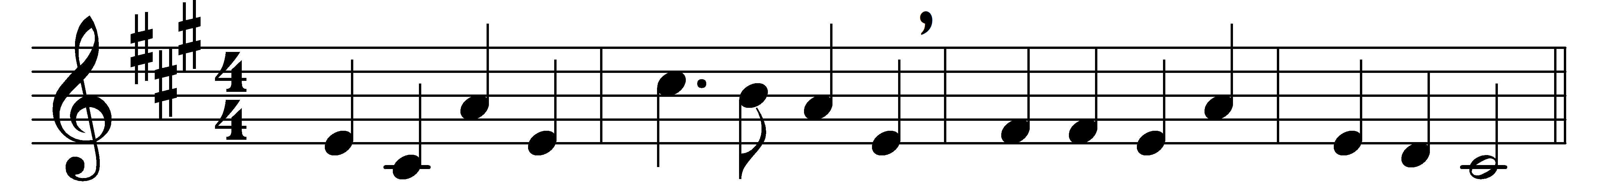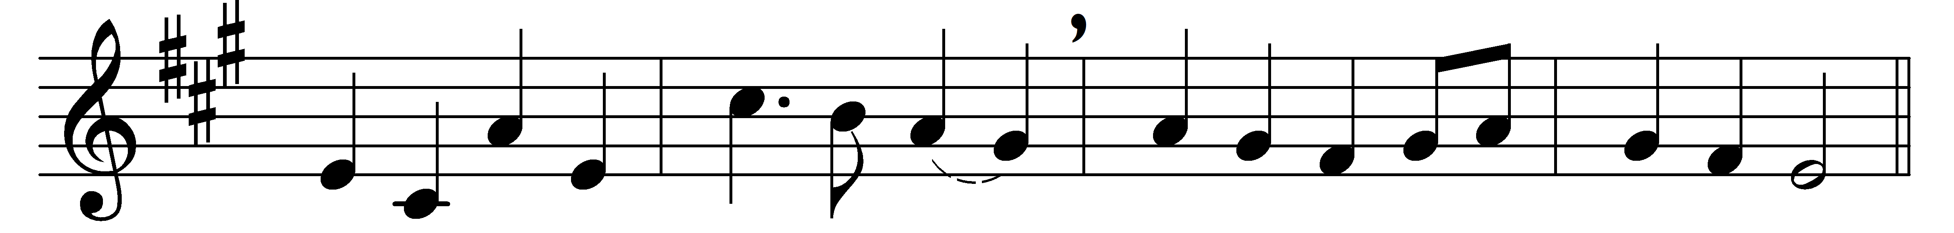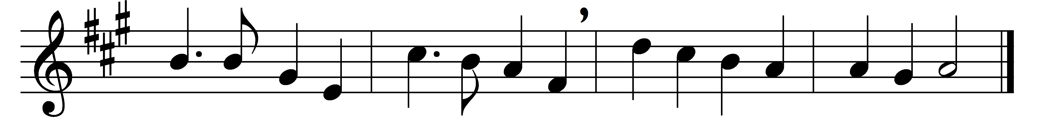

Christ is made the sure foundation,
Christ the head and cornerstone,
chosen of the Lord, and precious,
binding all the Church in one;
holy Zion’s help for ever,
and her confidence alone.

All that dedicated city,
dearly loved of God on high,
in exultant jubilation
pours perpetual melody;
God the One in Three adoring
in glad hymns eternally.

To this temple, where we call thee,
come, O Lord of Hosts, today;
with thy wonted loving-kindness
hear thy servants as they pray,
and thy fullest benediction
shed within its walls alway.

Here vouchsafe to all thy servants
what they ask of thee to gain;
what they gain from thee, for ever
with the blessèd to retain,
and hereafter in thy glory
evermore with thee to reign.

Words: Latin, c. 7th century, translation after John Mason Neale (1818-1866)
Music: Henry Thomas Smart (1813-1879)

