Come, gracious Spirit, heavenly Dove Hymnal 1982 no. 512 Melody: Mendon L.M.
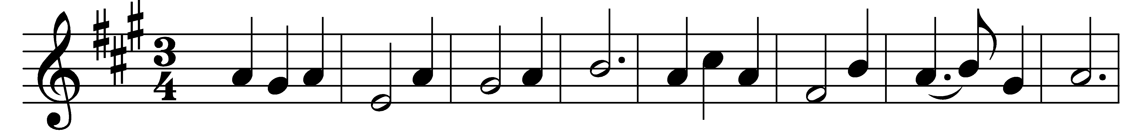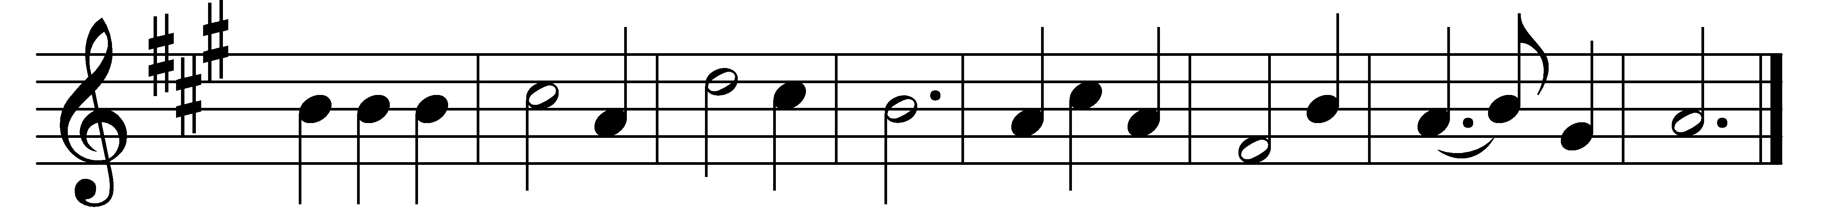

Come, gracious Spirit, heavenly Dove,
with light and comfort from above;
be thou our guardian, thou our guide
o’er every thought and step preside.

The light of truth to us display,
and make us know and choose thy way;
plant holy fear in every heart,
that we from thee may ne’er depart.

Lead us to Christ, the living way,
nor let us from his precepts stray;
lead us to holiness, the road
that we must take to dwell with God.

Lead us to heaven, that we may share
fullness of joy for ever there;
lead us to God, our final rest,
to be with him for ever blest.

Words: Simon Browne (1680-1732)
Music: From Methodist Harmonist, 1821, adapted and harmonised by Lowell Mason (1792-1872)

