Come, Holy Spirit, heavenly Dove Hymnal 1982 no. 510 Melody: St Agnes C.M.
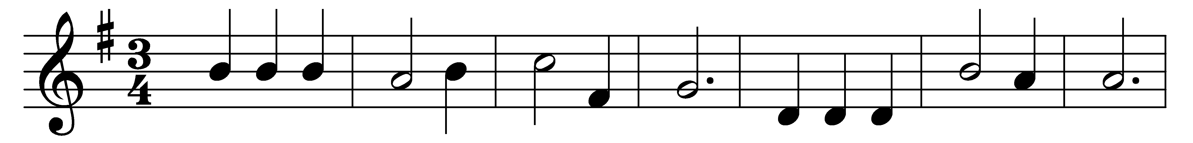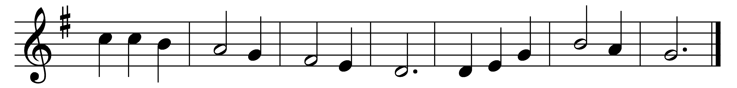

Come, Holy Spirit, heavenly Dove,
with all thy quickening powers;
kindle a flame of sacred love
in these cold hearts of ours.

See how we trifle here below,
fond of these earthly toys:
our souls, how heavily they go,
to reach eternal joys.

In vain we tune our formal songs,
in vain we strive to rise:
hosannas languish on our tongues,
and our devotion dies.

Come, Holy Spirit, heavenly Dove,
with all thy quickening powers;
come, shed abroad a Savior’s love,
and that shall kindle ours.

Words: Isaac Watts (1674-1748)
Music: John Bacchus Dykes (1823-1876)

