This is the day the Lord hath made Hymnal 1982 no. 50 Melody: London New C.M.
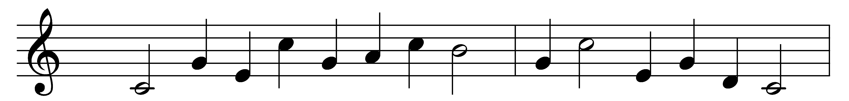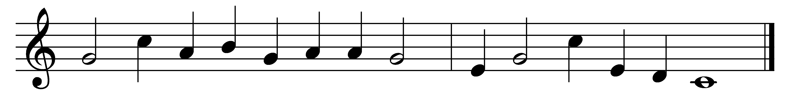

This is the day the Lord hath made,
he calls the hours his own;
let heaven rejoice, let earth be glad,
and praise surround the throne.
To-day he rose and left the dead,
and Satan’s empire fell;
to-day the saints his triumphs spread,
and all his wonders tell.
Hosanna to th’ anointed King,
to David’s holy Son!
Make haste to help us, Lord, and bring
salvation from thy throne.
Blest be the Lord, who comes to us
with messages of grace!
Who comes, in God his Father’s name,
to save our sinful race.
Hosanna in the highest strains
the Church on earth can raise;
the highest heavens in which he reigns
shall give him nobler praise.

Words: Isaac Watts (1674-1748)
Music: Melody from The Psalms of David in Prose and Meter (1635), harmonised by John Playford (1623-1686)

