O Spirit of Life, O Spirit of God Hymnal 1982 no 505 Melody: O heiliger Geist 10 8. 8 8. 10.
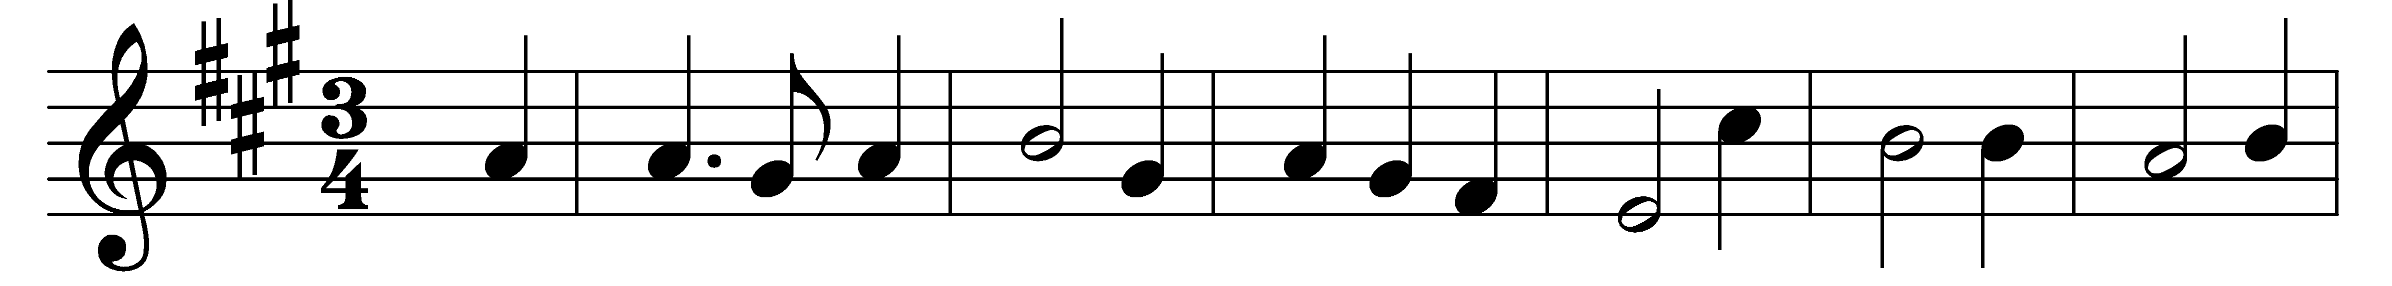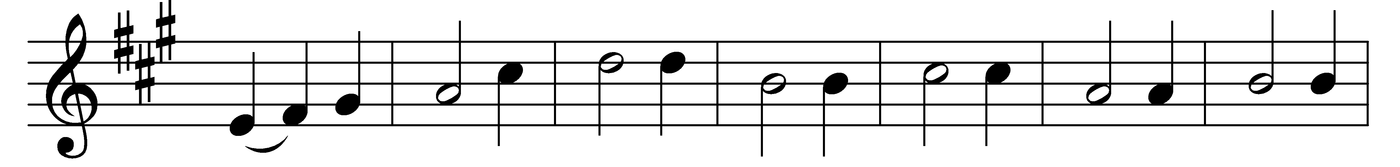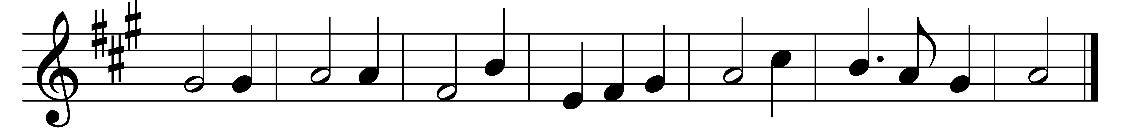

O Spirit of Life, O Spirit of God,
in every need thou bringest aid;
thou comest forth from God’s great throne,
from God, the Father and the Son;
O Spirit of Life, O Spirit of God.

O Spirit of Life, O Spirit of God,
increase our faith in our dear Lord;
unless thy grace the power should give,
none can believe in Christ and live;
O Spirit of Life, O Spirit of God.

O Spirit of Life, O Spirit of God,
make us to love thy sacred word;
the holy flame of love impart,
that charity may warm each heart;
O Spirit of Life, O Spirit of God.

O Spirit of Life, O Spirit of God,
enlighten us by that same word;
teach us to know the Father’s love,
and his dear Son, who reigns above;
O Spirit of Life, O Spirit of God.

Words: Johann Niedling (1602-1668), translated by John Caspar Mattes (1876-1948)
Music: Melody from Geistliche Kirchengesang, 1623

