Hosanna to the living Lord! Hymnal 1982 no. 486 Melody: Hosanna L.M. with refrain
British spelling
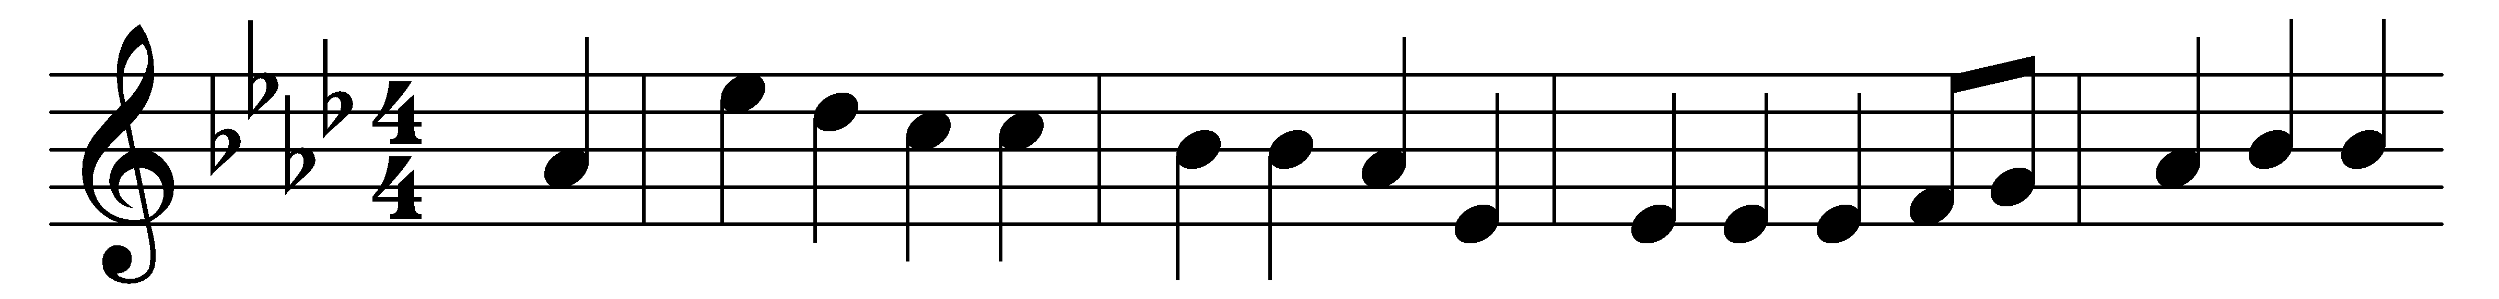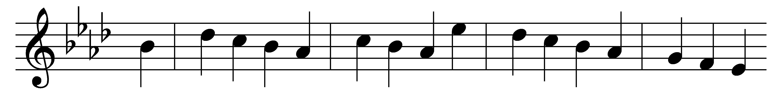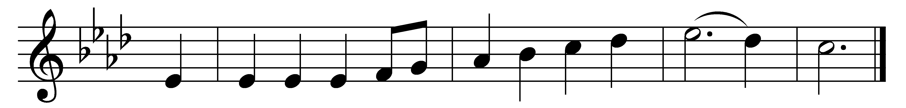

Hosanna to the living Lord!
Hosanna to th’ incarnate Word!
To Christ, Creator, Saviour, King,
let earth, let heaven, hosanna sing!
(Refrain:) Hosanna Lord! Hosanna in the highest!

Hosanna Lord! thine angels cry;
Hosanna Lord! thy saints reply;
above, beneath us, and around,
both dead and living swell the sound: (Refrain)

O Saviour, with protecting care
abide in this thy house of prayer,
where we assembled in thy Name,
in faith, thy parting promise claim. (Refrain)

But, chiefest, in our cleansèd breast,
Eternal! bid thy Spirit rest;
and make our secret soul to be
a temple pure and worthy thee. (Refrain)

So in the last and dreadful day,
when earth and heaven shall melt away,
thy flock, redeemed from sinful stain,
shall swell the sound of praise again. (Refrain)

Words: Reginald Heber (1783-1826)
Music: John Bacchus Dykes (1823-1876)

