There’s a wideness in God’s mercy Hymnal 1982 no. 470 Melody: Beecher 8 7. 8 7. D.
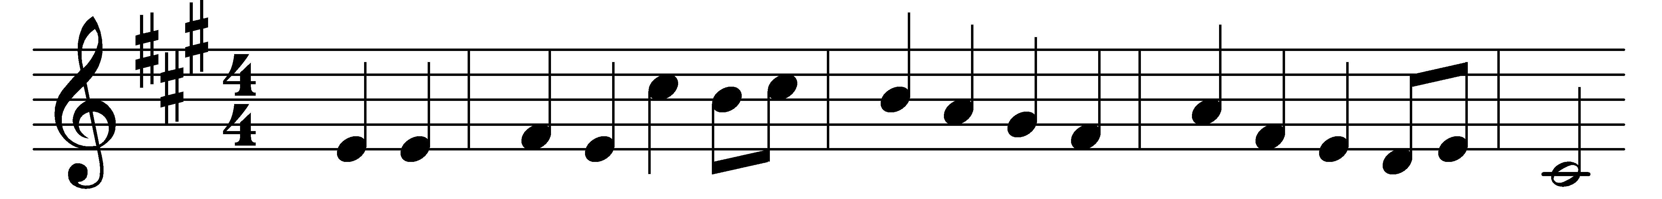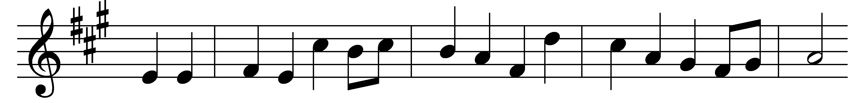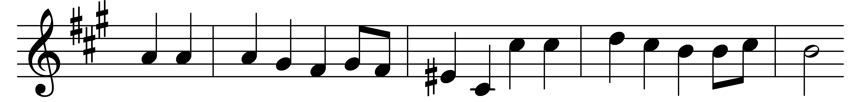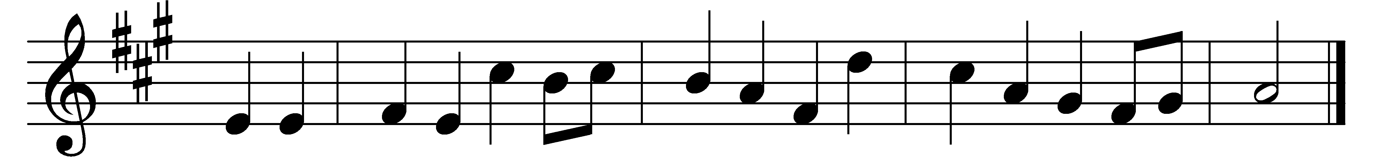

There’s a wideness in God’s mercy
like the wideness of the sea;
there’s a kindness in his justice,
which is more than liberty.
There is welcome for the sinner,
and more graces for the good;
there is mercy with the Savior;
there is healing in his blood.

There is no place where earth’s sorrows
are more felt than up in heaven;
there is no place where earth’s failings
have such kindly judgment given.
There is plentiful redemption
in the blood that has been shed;
there is joy for all the members
in the sorrows of the Head.

For the love of God is broader
than the measure of the mind;
and the heart of the Eternal
is most wonderfully kind.
If our love were but more faithful,
we should take him at his word;
and our life would be thanksgiving
for the goodness of the Lord.

Words: Frederick William Faber (1814-1863)
Music: John Zundel (1815-1882)

