The Lord will come and not be slow Hymnal 1982 no. 462 Melody: York C.M.

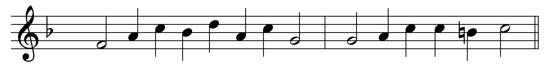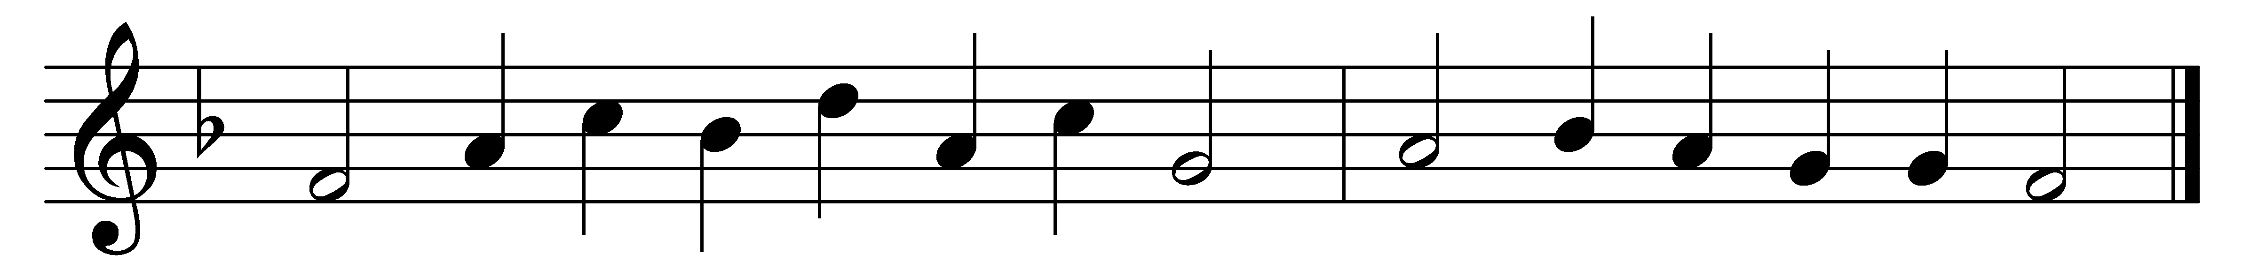

The Lord will come and not be slow,
his footsteps cannot err;
before him righteousness shall go,
his royal harbinger.

Truth from the earth, like to a flower,
shall bud and blossom show;
and justice, from her heavenly bower,
look down on us below.

Rise, God, judge thou the earth in might,
this wicked earth redress;
for thou art he who shalt by right
the nations all possess.

The nations all whom thou hast made
shall come, and all shall frame
to bow them low before thee, Lord,
and glorify thy Name.

For great thou art, and wonders great
by thy strong hand are done:
thou in thy everlasting seat
remainest God alone.

Words: John Milton (1608-1674)
Music: Melody from The CL Psalmes of David, 1615, adapted in The Whole Booke of Psalmes, 1621; harmony by John Milton, Senior (1563?-1647)

