My song is love unknown Hymnal 1982 no. 458 Melody: Rhosymedre 6 6. 6 6. 8 8 8.
Words from AMNS
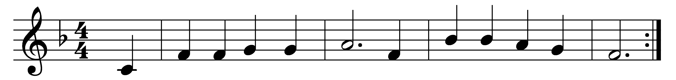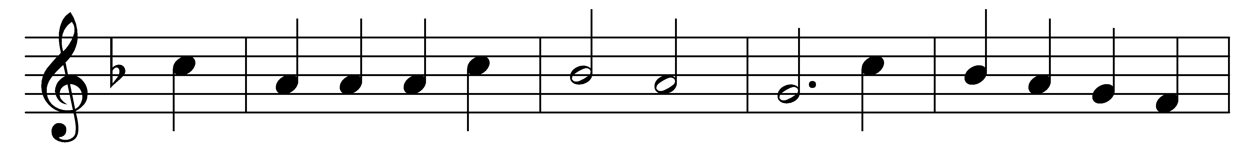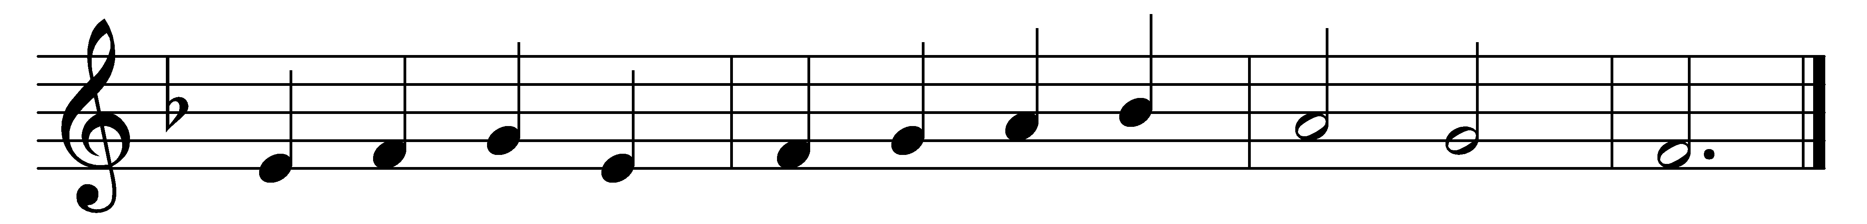

My song is love unknown,
my Saviour’s love to me,
love to the loveless shown,
that they might lovely be.
O who am I, that for my sake
my Lord should take frail flesh, and die,
my Lord should take frail flesh, and die?

He came from his blest throne,
salvation to bestow;
but men made strange, and none
the longed-for Christ would know.
But O, my Friend, my Friend indeed,
who at my need his life did spend,
who at my need his life did spend!

Sometimes they strew his way,
and his sweet praises sing;
resounding all the day
hosannas to their King.
Then ‘Crucify!’ is all their breath,
and for his death they thirst and cry,
and for his death they thirst and cry.

Why, what hath my Lord done?
What makes this rage and spite?
He made the lame to run,
he gave the blind their sight.
Sweet injuries! yet they at these
themselves displease, and ’gainst him rise,
themselves displease, and ’gainst him rise.

They rise, and needs will have
my dear Lord made away;
a murderer they save,
the Prince of Life they slay.
Yet cheerful he to suffering goes,
that he his foes from thence might free,
that he his foes from thence might free.

In life, no house, no home
my Lord on earth might have;
in death, no friendly tomb
but what a stranger gave.
What may I say? Heaven was his home;
but mine the tomb wherein he lay,
but mine the tomb wherein he lay.

Here might I stay and sing:
no story so divine;
never was love, dear King,
never was grief like thine!
This is my Friend, in whose sweet praise
I all my days could gladly spend,
I all my days could gladly spend.

Words: Samuel Crossman (1624-1683)
Music: John Edwards (1806-1885)

