O love, how deep, how broad, how high Hymnal 1982 no. 449 Melody: Deo gracias L.M.

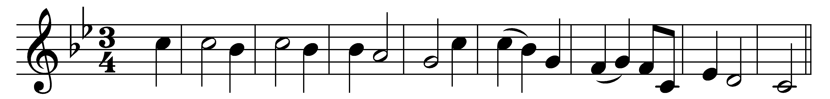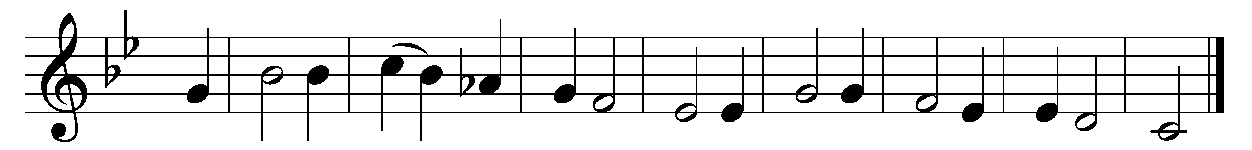

O love, how deep, how broad, how high,
how passing thought and fantasy,
that God, the Son of God, should take
our mortal form for mortals’ sake.

For us baptized, for us he bore
his holy fast and hungered sore;
for us temptations sharp he knew;
for us the tempter overthrew.

For us he prayed; for us he taught;
for us his daily works he wrought:
by words and signs and actions, thus
still seeking not himself, but us.

For us to wicked hands betrayed,
scourged, mocked, in purple robe arrayed,
he bore the shameful cross and death;
for us gave up his dying breath.

For us he rose from death again;
for us he went on high to reign;
for us he sent his Spirit here
to guide, to strengthen, and to cheer.

All glory to our Lord and God
for love so deep, so high, so broad;
the Trinity whom we adore
for ever and for evermore.

Words: Latin, 15th century, translated by Benjamin Webb (1819-1885)
Music: English ballad melody, Trinity College MS, 15th century, harmony from Hymns Ancient and Modern Revised

