Praise to the Holiest in the height 1982 no. 446 Melody: Newman C.M.
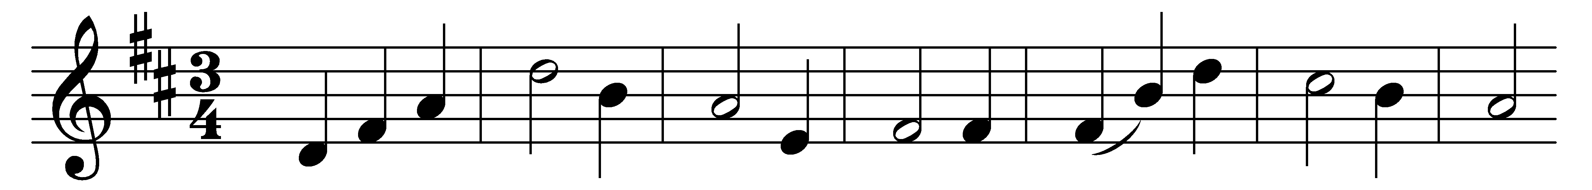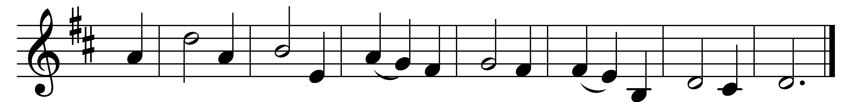

Praise to the Holiest in the height,
and in the depth be praise;
in all his words most wonderful,
most sure in all his ways!

O loving wisdom of our God!
When all was sin and shame,
a second Adam to the fight
and to the rescue came.

O wisest love! that flesh and blood,
which did in Adam fail,
should strive afresh against the foe,
should strive, and should prevail;

and that the highest gift of grace
should flesh and blood refine:
God’s presence and his very self,
and essence all-divine.

Praise to the Holiest in the height,
and in the depth be praise;
in all his words most wonderful,
most sure in all his ways!

Words: John Henry Newman (1801-1890)
Music: Richard Runciman Terry (1865-1938)

