In the cross of Christ I glory Hymnal 1982 no. 441 Melody: Charlestown 8 7. 8 7.
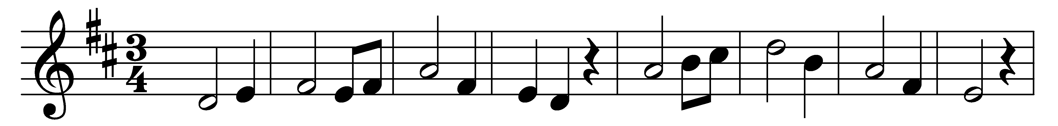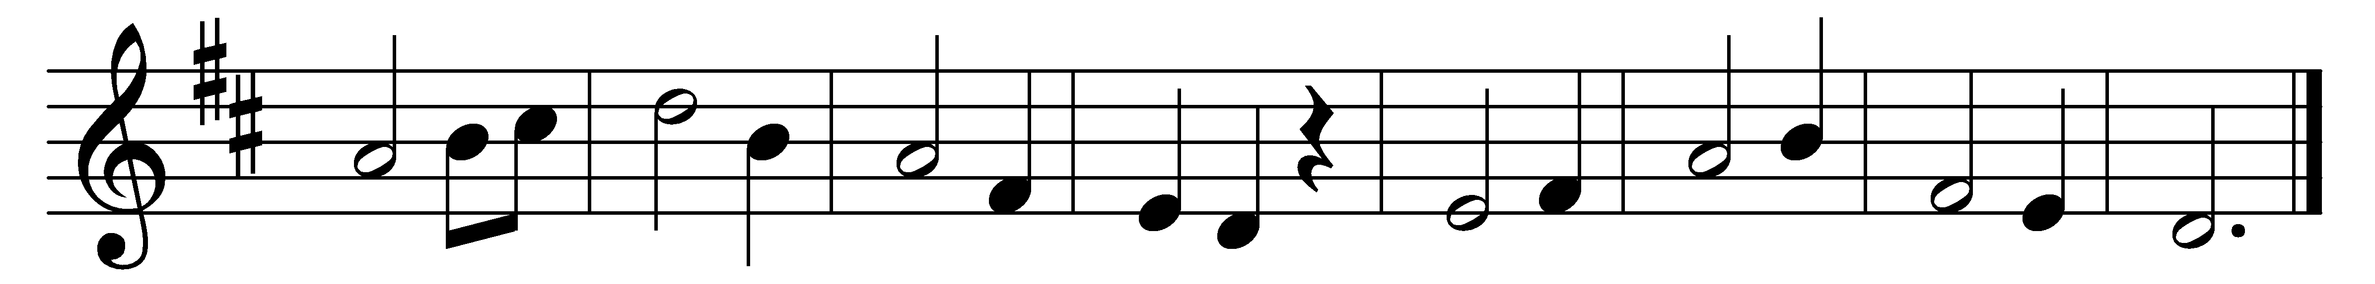

In the cross of Christ I glory,
towering o’er the wrecks of time;
all the light of sacred story
gathers round its head sublime.

When the woes of life o’ertake me,
hopes deceive, and fears annoy,
never shall the cross forsake me:
lo, it glows with peace and joy.

When the sun of bliss is beaming
light and love upon my way,
from the cross the radiance streaming
adds new luster to the day.

Bane and blessing, pain and pleasure,
by the cross are sanctified;
peace is there that knows no measure,
joys that through all time abide.

In the cross of Christ I glory,
towering o’er the wrecks of time;
all the light of sacred story
gathers round its head sublime.

Words: John Bowring (1792-1872)
Music: The Southern Harmony, 1835

