Blessed Jesus, at thy word Hymnal 1982 no. 440 Melody: Liebster Jesu 7 8. 7 8. 8 8.
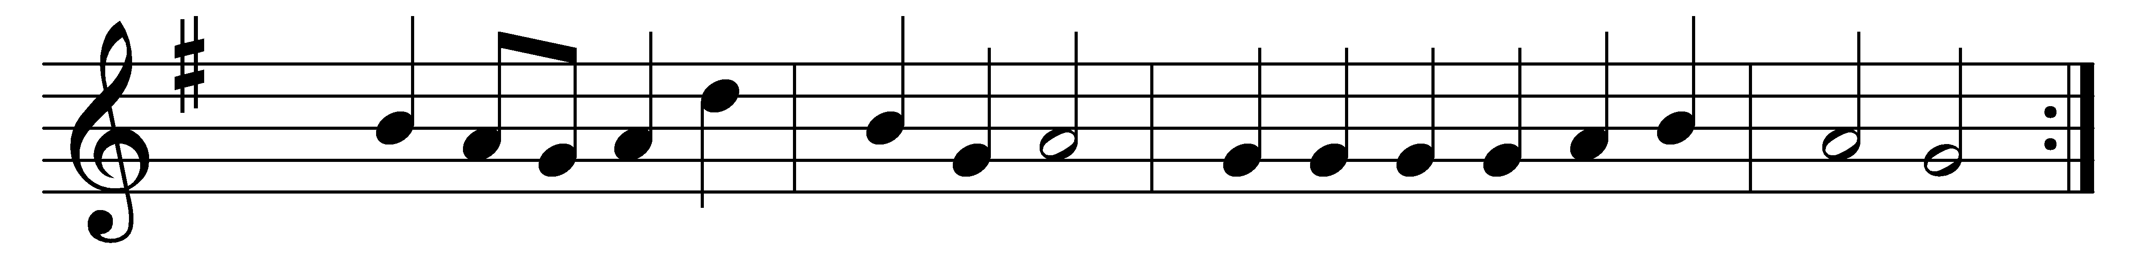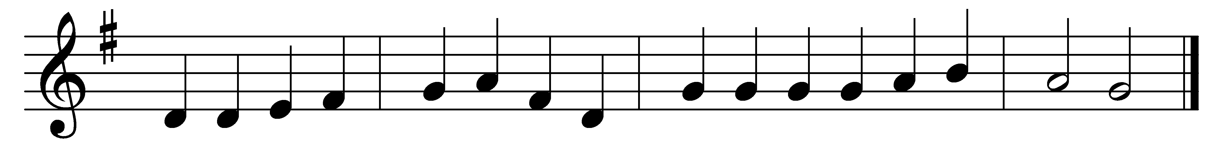

Blessèd Jesus, at thy word
we are gathered all to hear thee;
let our hearts and souls be stirred
now to seek and love and fear thee;
by thy teachings pure and holy,
drawn from earth to love thee solely.

All our knowledge, sense, and sight
lie in deepest darkness shrouded,
till thy Spirit breaks our night
with the beams of truth unclouded;
thou alone to God canst win us;
thou must work all good within us.

Gracious Lord, thyself impart!
Light of Light, from God proceeding,
open thou our ears and heart,
help us by thy Spirit’s pleading.
Hear the cry thy Church upraises;
hear, and bless our prayers and praises.

Words: Tobias Clausnitzer (1619-1684), translated by Catherine Winkworth (1827-1878)
Music: Melody by Johann Rudolph Ahle (1625-1673), harmonised by George Herbert Palmer (1846-1926)

