Nature with open volume stands Hymnal 1982 no. 434 Melody: Eltham L.M.
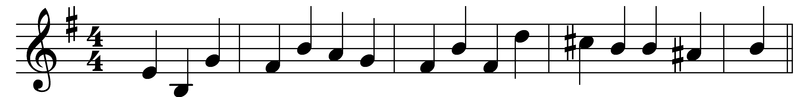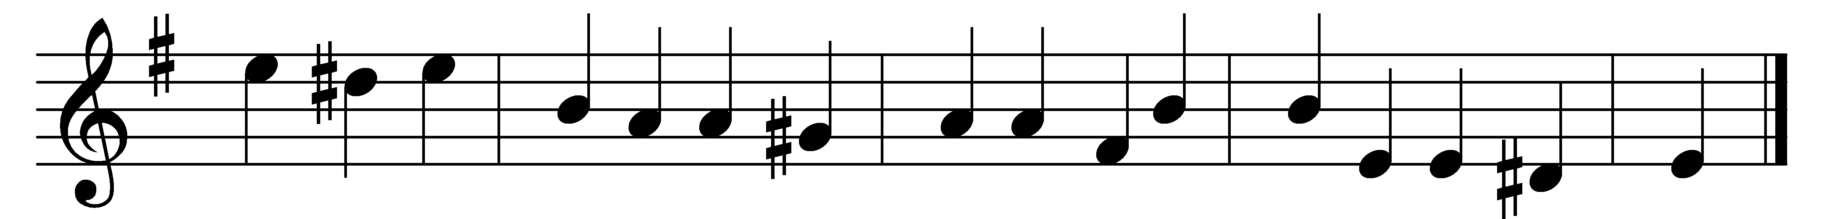

Nature with open volume stands
to spread her Maker’s praise abroad
and every labor of his hands
shows something worthy of a God.

But in the grace that rescued man
his brightest form of glory shines;
here, on the cross, ’tis fairest drawn
in precious blood and crimson lines.

Here his whole Name appears complete;
nor wit can guess, nor reason prove
which of the letters best is writ,
the power, the wisdom, or the love.

Oh, the sweet wonders of that cross
where Christ my Savior loved and died!
Her noblest life my spirit draws
from his dear wounds and bleeding side.

I would for ever speak his Name
in sounds to mortal ears unknown,
with angels join to praise the Lamb
and worship at his Father’s throne!

Words: Isaac Watts (1674-1748)
Music: Melody by Nathaniel Gawthorn (18th century), harmony by Samuel Sebastian Wesley (1810-1876)

