We gather together to ask the Lord’s blessing Hymnal 1982 no. 433
Melody: Kremser 12 11. 12 11.

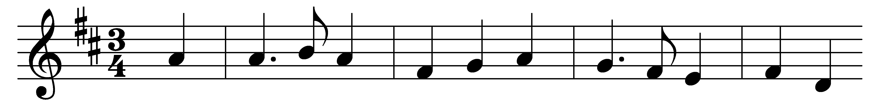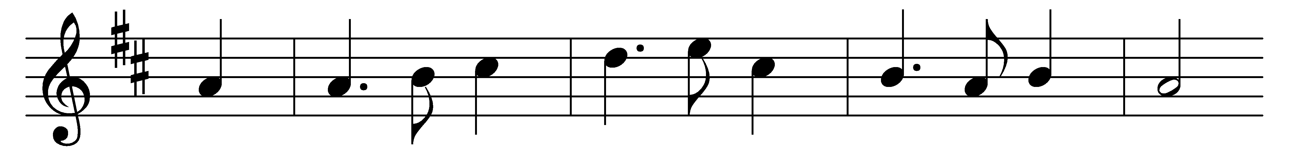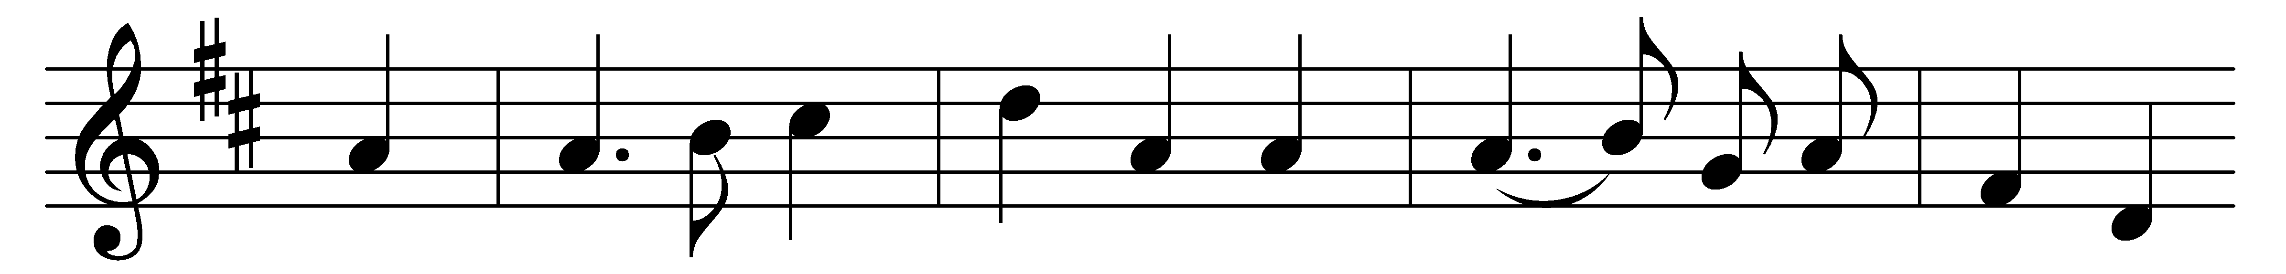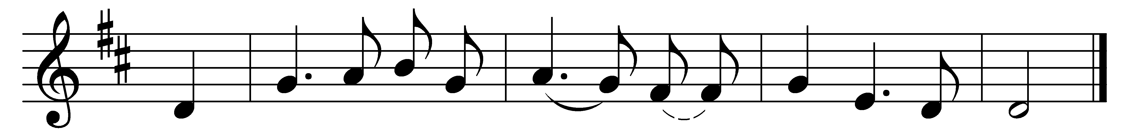

We gather together
to ask the Lord’s blessing;
he chastens and hastens
his will to make known;
the wicked oppressing
now cease from distressing:
sing praises to his Name;
he forgets not his own.

Beside us to guide us,
our God with us joining,
ordaining, maintaining
his kingdom divine;
so from the beginning
the fight we were winning:
thou, Lord, wast at our side:
all glory be thine!

We all do extol thee,
thou leader triumphant,
and pray that thou still
our defender wilt be.
Let thy congregation
escape tribulation:
thy Name be ever praised!
O Lord, make us free!

Words: Anonymous, 1625, translated by Theodore Baker (1851-1934)
Music: From Nederlandtsch Gedenckclank, 1626, arranged by Eduard Kremser (1838-1914)

