Come, O come, our voices raise Hymnal 1982 no. 430
Melody: Sonne der Gerechtigkeit 7 7. 7 7. with Alleluia
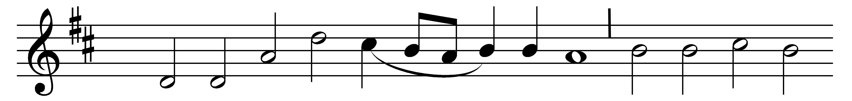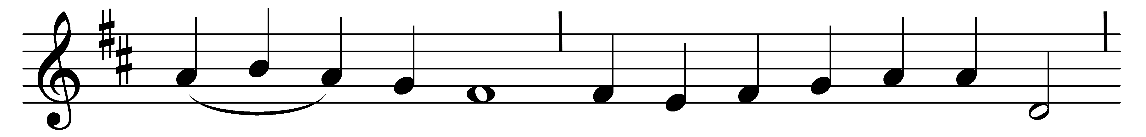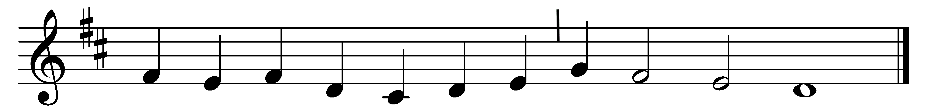

Come, O come, our voices raise,
sounding God Almighty’s praise;
hither bring in one consent
heart, and voice, and instrument.
Alleluia!

Sound the trumpet, touch the lute,
let no tongue nor string be mute,
nor a voiceless creature found,
that hath neither note nor sound.
Alleluia!

Come ye all before his face,
in this chorus take your place;
and amid the mortal throng,
be you masters of the song.
Alleluia!

Let, in praise of God, the sound
run a never-ending round,
that our songs of praise may be
everlasting, as is he.
Alleluia!

So this huge wide orb we see
shall one choir, one temple be;
where in such a praiseful tone
we will sing what he hath done.
Alleluia!

Thus our song shall overclimb
all the bounds of space and time;
come, then, come, our voices raise,
sounding God Almighty’s praise.
Alleluia!

Words: George Wither (1588-1667)
Music: Melody from Bohemian Brethren, Kirchengesang, 1566

