I’ll praise my Maker while I’ve breath Hymnal 1982 no. 429 Melody: Old 113th 8 8. 8 8. 8 8.
British spelling
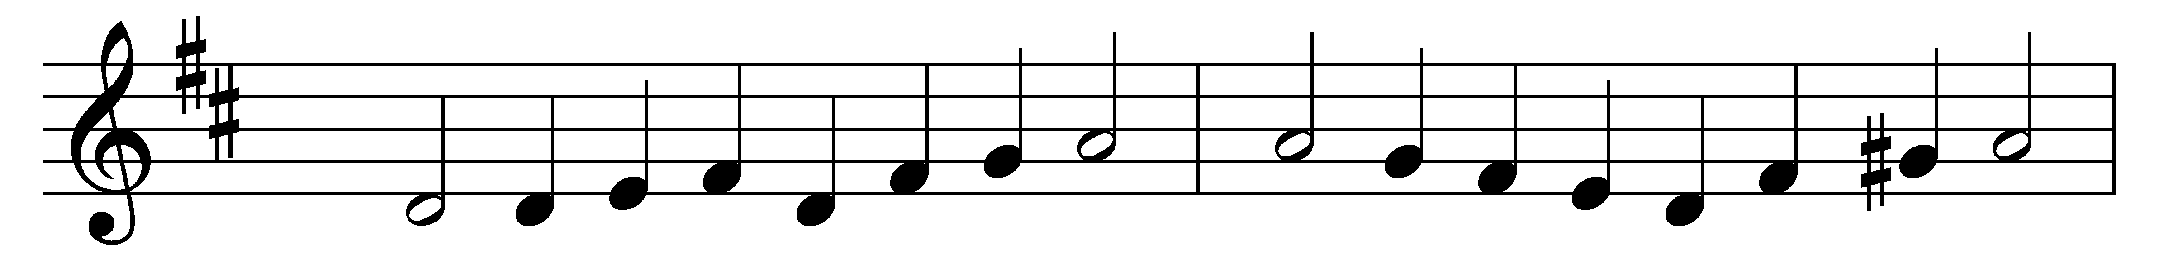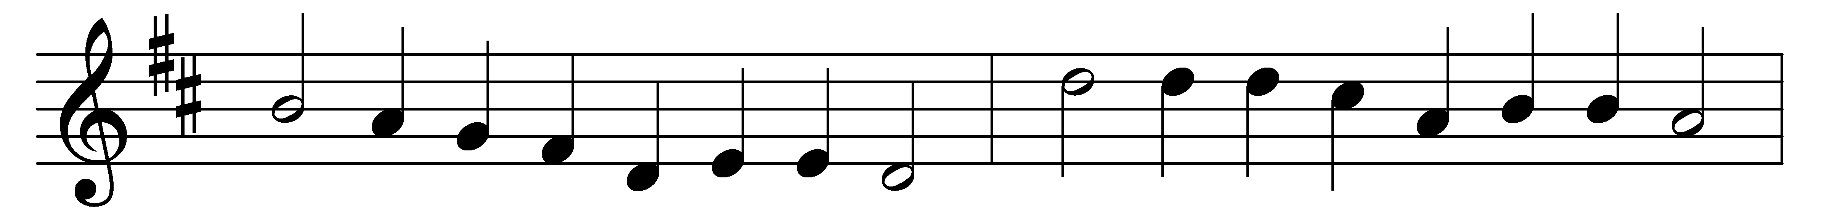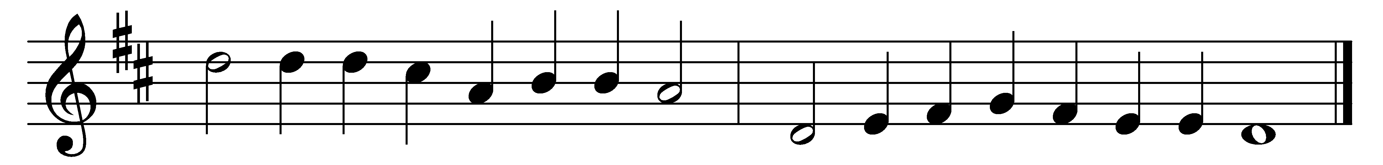

I’ll praise my Maker while I’ve breath;
and when my voice is lost in death,
praise shall employ my nobler powers.
My days of praise shall ne’er be past
while life and thought and being last,
or immortality endures.

How happy they whose hopes rely
on Israel’s God, who made the sky
and earth and seas with all their train;
whose truth for ever stands secure,
who saves th’ oppressed, and feeds the poor.
And none shall find his promise vain.

The Lord pours eyesight on the blind;
the Lord supports the fainting mind
and sends the labouring conscience peace.
He helps the stranger in distress,
the widowed and the fatherless,
and grants the prisoner sweet release.

I’ll praise him while he lends me breath;
and when my voice is lost in death,
praise shall employ my nobler powers.
My days of praise shall ne’er be past
while life and thought and being last,
or immortality endures.

Words: Isaac Watts (1674-1748), altered by John Wesley (1703-1791)
Music: From Strassburger Kirchenamt, 1525

