Lord of all being, throned afar Hymnal 1982 no. 419 Melody: Mendon L.M.
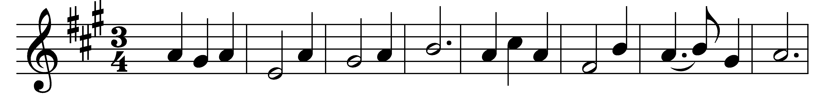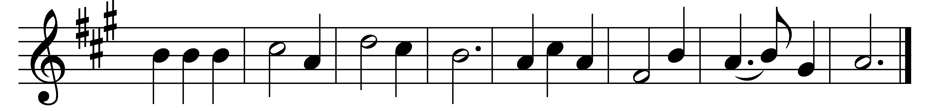

Lord of all being, throned afar,
thy glory flames from sun and star;
center and soul of every sphere,
yet to each loving heart how near!

Sun of our life, thy quickening ray
sheds on our path the glow of day;
star of our hope, thy softened light
cheers the long watches of the night.

Lord of all life, below, above,
whose light is truth, whose warmth is love,
before thy ever-blazing throne
we ask no luster of our own.

Grant us thy truth to make us free,
and kindling hearts that burn for thee,
till all thy living altars claim
one holy light, one heavenly flame.

Words: Oliver Wendell Holmes (1809-1894)
Music: From Methodist Harmonist, 1821, adapted and harmonised by Lowell Mason (1792-1872)

