O bless the Lord, my soul! Hymnal 1982 no. 411 Melody: St Thomas S.M.
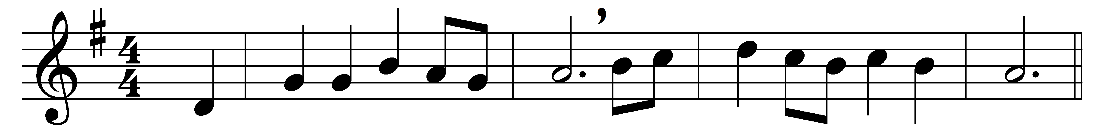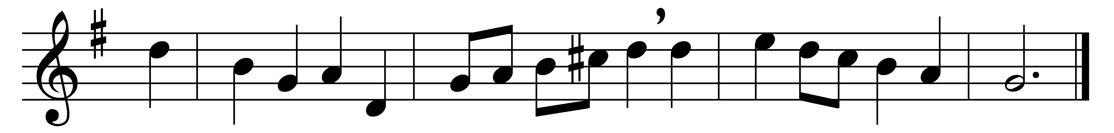

O bless the Lord, my soul!
His grace to thee proclaim!
And all that is within me join
to bless his holy Name!

O bless the Lord, my soul!
His mercies bear in mind!
Forget not all his benefits!
The Lord to thee is kind.

He will not always chide;
he will with patience wait;
his wrath is ever slow to rise
and ready to abate.

He pardons all thy sins,
prolongs thy feeble breath;
he healeth thine infirmities
and ransoms thee from death.

He clothes thee with his love,
upholds thee with his truth;
and like the eagle he renews
the vigor of thy youth.

Then bless his holy Name,
whose grace hath made thee whole,
whose loving-kindness crowns thy days:
O bless the Lord, my soul!

Words: James Montgomery (1771-1854)
Music: Melody by Aaron Williams (1731-1776), harmony by Lowell Mason (1792-1872)

