From all that dwell below the skies Hymnal 1982 no. 380 Melody: Old 100th L.M.
Words from AMNS
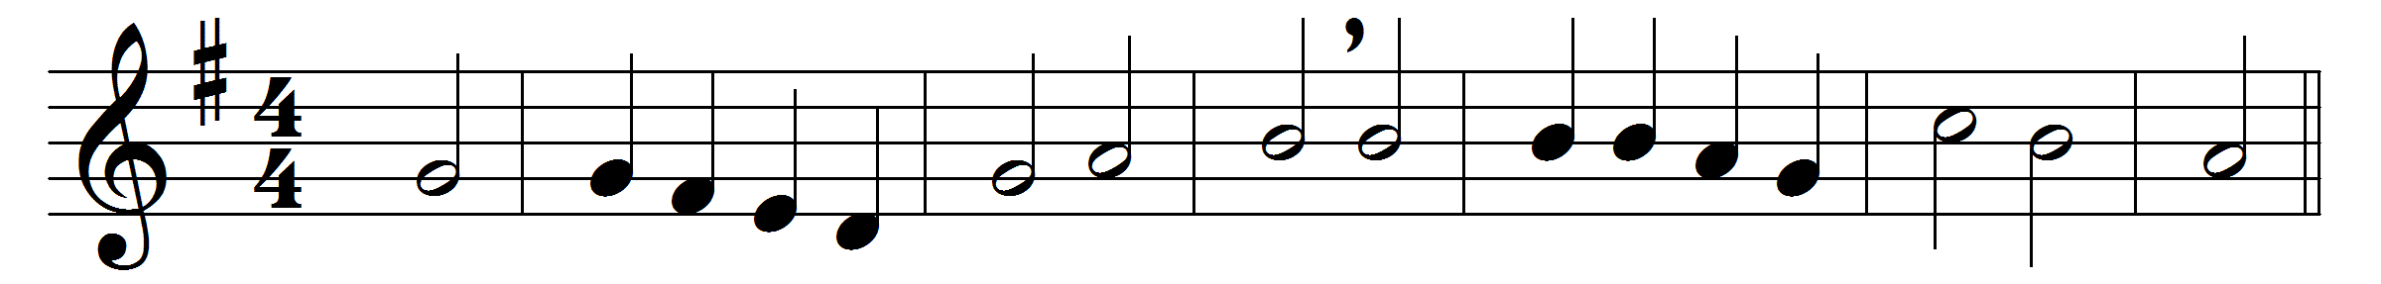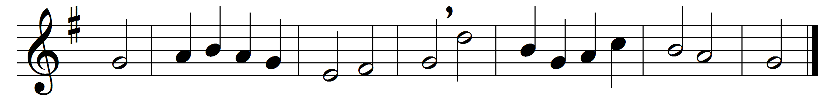

From all that dwell below the skies,
let the Creator’s praise arise:
let the Redeemer’s name be sung
through every land by every tongue.

Eternal are thy mercies, Lord;
eternal truth attends thy word:
thy praise shall sound from shore to shore,
till suns shall rise and set no more.

Words: Isaac Watts (1674-1748)
Music: Melody in Genevan Psalter, 1551

