Joyful, joyful, we adore thee Hymnal 1982 no. 376 Melody: Hymn to Joy 8 7. 8 7. D.
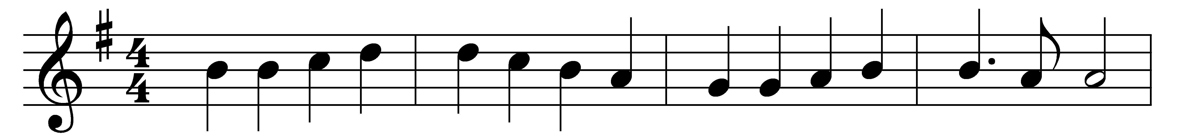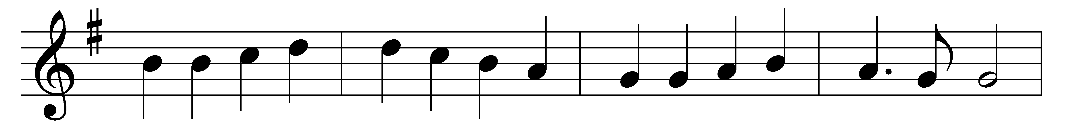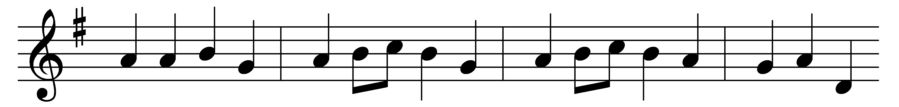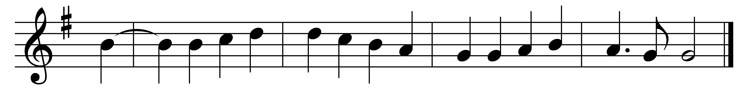

Joyful, joyful, we adore thee,
God of glory, Lord of love;
hearts unfold like flowers before thee,
praising thee, their sun above.
Melt the clouds of sin and sadness;
drive the dark of doubt away;
giver of immortal gladness,
fill us with the light of day.

All thy works with joy surround thee,
earth and heaven reflect thy rays,
stars and angels sing around thee,
center of unbroken praise.
Field and forest, vale and mountain,
blooming meadow, flashing sea,
chanting bird and flowing fountain,
call us to rejoice in thee.

Thou art giving and forgiving,
ever blessing, ever blest,
wellspring of the joy of living,
ocean-depth of happy rest!
Thou our Father, Christ our Brother:
all who live in love are thine;
teach us how to love each other,
lift us to the joy divine.

Words: Henry Van Dyke (1852-1933)
Melody: Ludwig van Beethoven (1770-1827), adapted by Edward Hodges (1796-1867)

