Come, let us join our cheerful songs Hymnal 1982 no. 374 Melody: Nun danket all C.M.
Words from AMNS
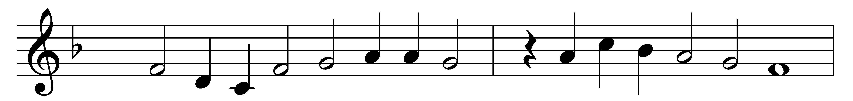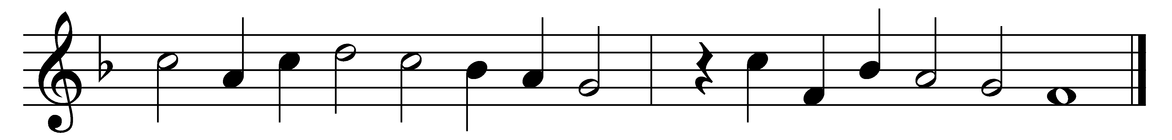

Come, let us join our cheerful songs
with angels round the throne;
ten thousand thousand are their tongues,
but all their joys are one.

‘Worthy the Lamb that died,’ they cry,
‘to be exalted thus;’
‘worthy the Lamb,’ our lips reply,
‘for he was slain for us.’

Jesus is worthy to receive
honour and power divine;
and blessings, more than we can give,
be, Lord, for ever thine.

Let all creation join in one
to bless the sacred name
of him that sits upon the throne,
and to adore the Lamb.

Words: Isaac Watts (1674-1748)
Melody: Attributed to Johann Crüger (1598-1662)

