Praise to the living God! Hymnal 1982 no. 372 Melody: Leoni 6 6. 8 4. D.
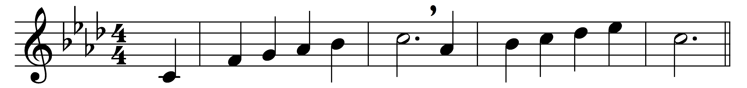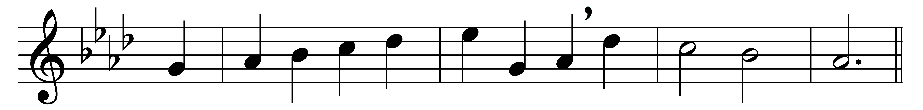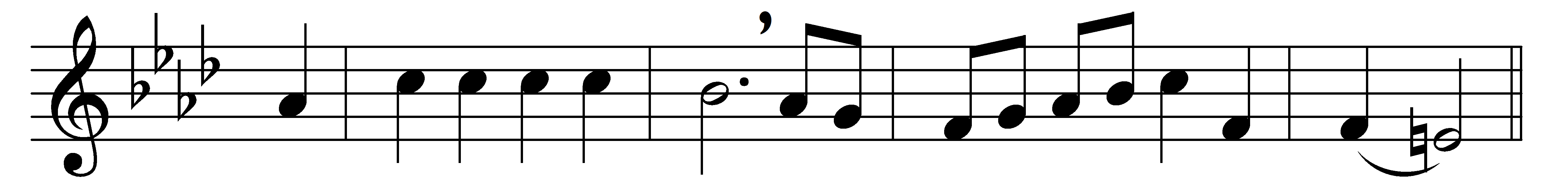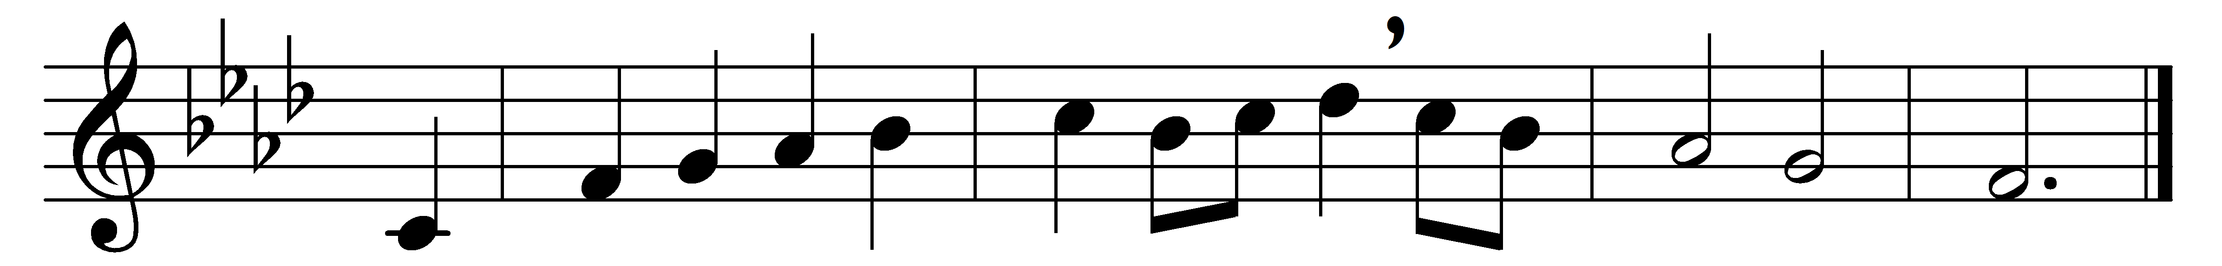

Praise to the living God!
All praisèd be his Name
who was, and is, and is to be,
for ay the same.
The one eternal God
ere aught that now appears:
the first, the last, beyond all thought
his timeless years!

Formless, all lovely forms
declare his loveliness;
holy, no holiness of earth
can his express.
Lo, he is Lord of all.
Creation speaks his praise,
and everywhere above, below,
his will obeys.

His Spirit floweth free,
high surging where it will:
in prophet’s word he spoke of old;
he speaketh still.
Established is his law,
and changeless it shall stand,
deep writ upon the human heart,
on sea, on land.

Eternal life hath he
implanted in the soul;
his love shall be our strength and stay
while ages roll.
Praise to the living God!
All praisèd be his Name
who was, and is, and is to be,
for ay the same.

Words: Medieval Jewish liturgy, translated by Max Landsberg (1845-1928) and Newton M. Mann (1836-1926)
Music: Hebrew traditional melody

