O gladsome Light, O grace Hymnal 1982 no. 36 Melody: Le Cantique de Siméon 6 6 7. 6 6 7.
British spelling
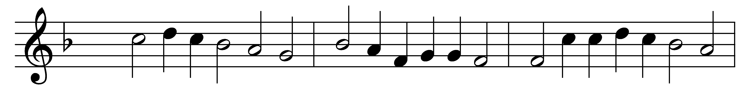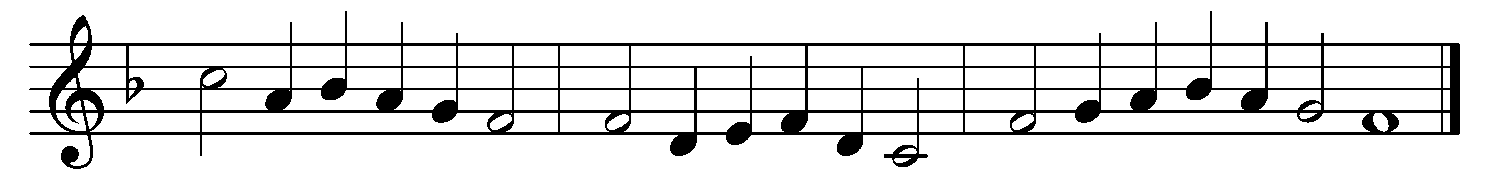

O gladsome Light, O grace
of God the Father’s face,
th’ eternal splendour wearing;
celestial, holy, blest,
our Saviour Jesus Christ,
joyful in thine appearing.

Now, ere day fadeth quite,
we see the evening light,
our wonted hymn outpouring;
Father of might unknown,
thee, his incarnate Son,
and Holy Spir’t adoring.

To thee of right belongs
all praise of holy songs,
O Son of God, Life-giver;
thee, therefore, O Most High,
the world doth glorify,
and shall exalt forever.

Words: 3rd-century Greek, translated by Robert Seymour Bridges (1844-1930)
Music: Melody by Louis Bourgeois (c.1510-c.1561), harmony by Claude Goudimel (1514-1572)

