Holy Father, great Creator Hymnal 1982 no. 368 Melody: Regent Square 8 7. 8 7. 8 7.
British spelling
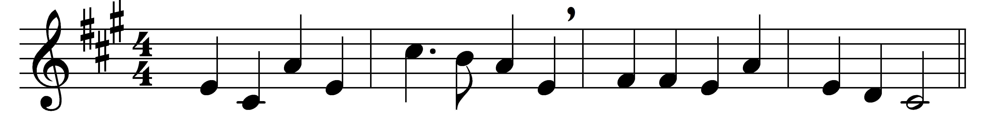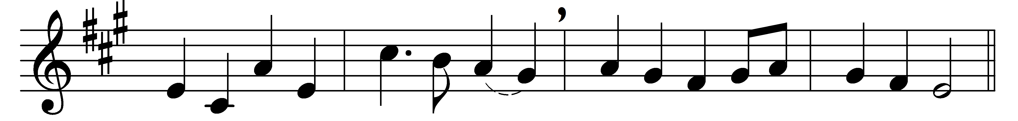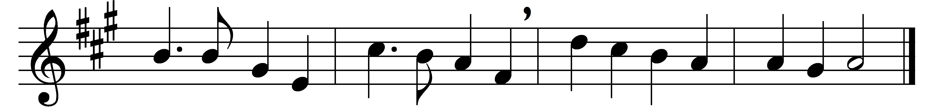

Holy Father, great Creator,
source of mercy, love, and peace,
look upon the Mediator,
clothe us with his righteousness;
heavenly Father, heavenly Father,
through the Saviour hear and bless.

Holy Jesus, Lord of glory,
whom angelic hosts proclaim,
while we hear thy wondrous story,
meet and worship in thy Name,
dear Redeemer, dear Redeemer,
in our hearts thy peace proclaim.

Holy Spirit, Sanctifier,
come with unction from above,
touch our hearts with sacred fire,
fill them with the Saviour’s love.
Source of comfort, Source of comfort,
cheer us with the Saviour’s love.

God the Lord, through every nation
let thy wondrous mercies shine.
In the song of thy salvation
every tongue and race combine.
Great Jehovah, Great Jehovah,
form our hearts and make them thine.

Words: Alexander Viets Griswold (1766-1843)
Music: Henry Thomas Smart (1813-1879)

