Only-begotten, Word of God eternal Hymnal 1982 no. 360 Melody: Rouen 11 11. 11 5.
British spelling
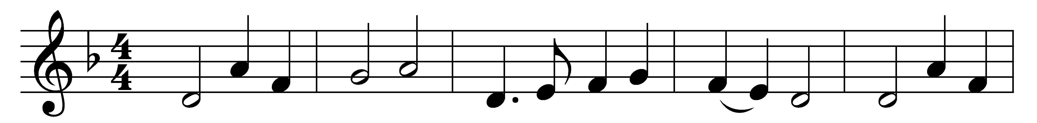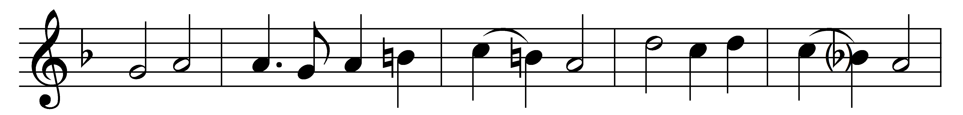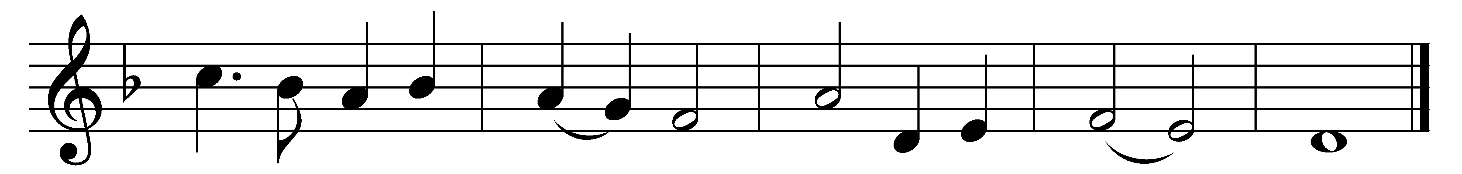

Only-begotten, Word of God eternal,
Lord of creation, merciful and mighty,
hear now thy servants when their joyful voices
rise to thy presence.

This is thy temple; here thy presence-chamber;
here may thy servants, at the mystic banquet,
humbly adoring, take thy Body broken,
drink of thy chalice.

Here in our sickness healing grace aboundeth,
light in our blindness, in our toil refreshment:
sin is forgiven, hope o’er fear prevaileth,
joy over sorrow.

Hallowed this dwelling where the Lord abideth,
this is none other than the gate of heaven;
strangers and pilgrims, seeking homes eternal,
pass through its portals.

Lord, we beseech thee, as we throng thy temple,
by thy past blessings, by thy present bounty,
favour thy children, and with tender mercy
hear our petitions.

God in three Persons, Father everlasting,
Son co-eternal, ever-blessèd Spirit,
thine be the glory, praise, and adoration,
now and for ever.

Words: Latin, c. 9th century, translated by Maxwell Julius Blacker (1822-1888)
Music: Melody from Vesperale, 1746

