May the grace of Christ our Saviour Hymnal 1982 no. 351 Melody: Halton Holgate 8 7. 8 7.
Words from AMNS
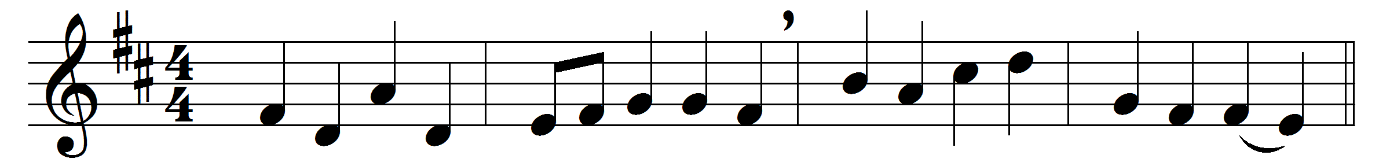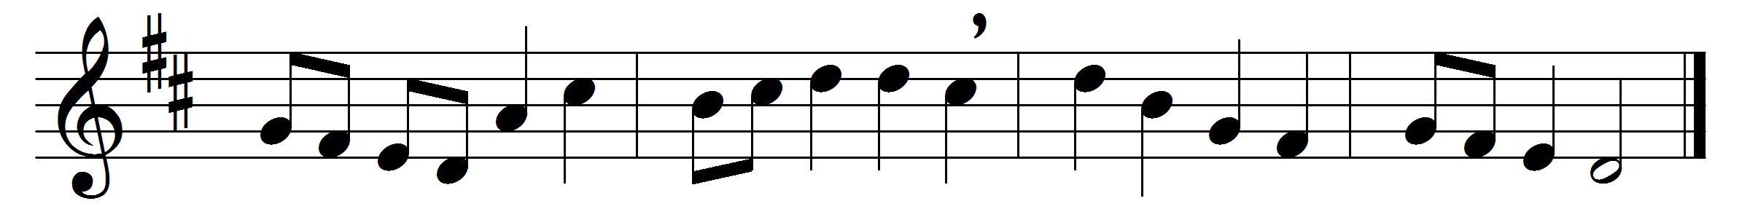

May the grace of Christ our Saviour,
and the Father’s boundless love,
with the Holy Spirit’s favour,
rest upon us from above.

Thus may we abide in union
with each other and the Lord,
and possess, in sweet communion,
joys which earth cannot afford.

Words: John Newton (1725-1807)
Music: Later form of melody by William Boyce (c. 1710-1779)

