May the grace of Christ our Savior Hymnal 1982 no. 351 Melody: Halton Holgate 8 7. 8 7.
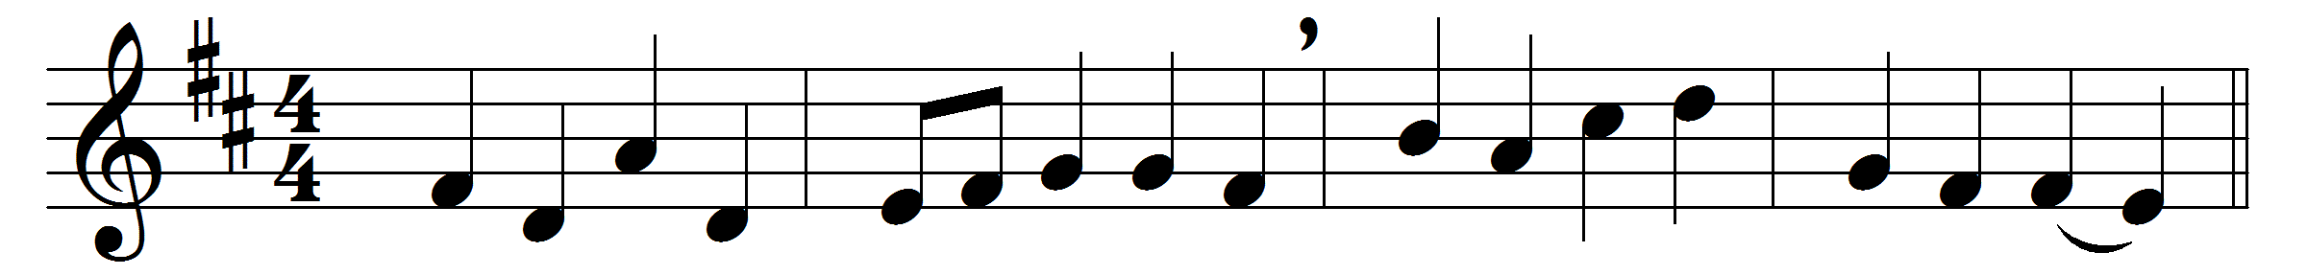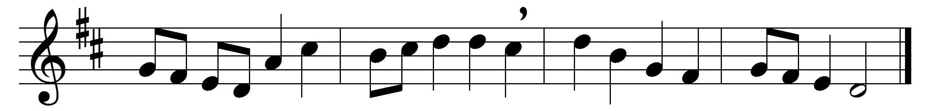

May the grace of Christ our Savior,
and the Father’s boundless love,
with the Holy Spirit’s favor,
rest upon them from above.

Thus may they abide in union
with each other and the Lord,
and possess, in sweet communion,
joys which earth cannot afford.

Words: John Newton (1725-1807)
Music: Later form of melody by William Boyce (c. 1710-1779)

