Holy Spirit, Lord of love Hymnal 1982 no. 349 Melody: Aberystwyth 7 7. 7 7. D.
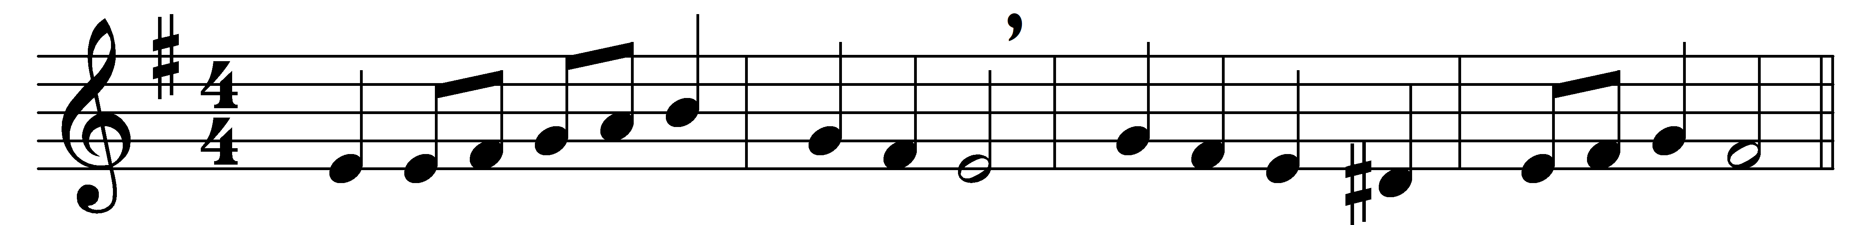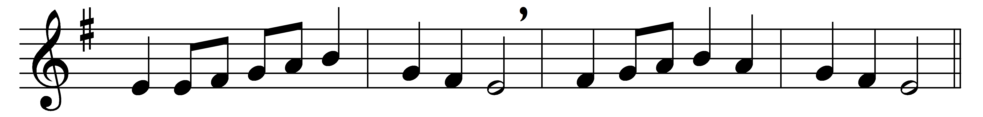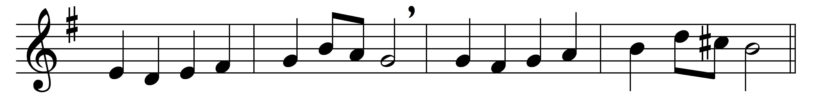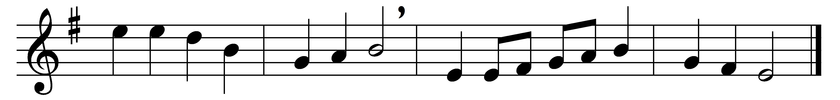

Holy Spirit, Lord of love,
who descended from above,
gifts of blessing to bestow
on your waiting Church below,
once again in love draw near
to your servants gathered here;
from their bright baptismal day
you have led them on their way.

When the sacred vow is made,
when the hands are on them laid,
come in this most solemn hour
with your strengthening gift of power.
Give them light, your truth to see;
give them life, your own to be;
daily power to conquer sin;
patient faith, the crown to win.

Words: William Dalrymple Maclagan (1826-1910)
Music: Joseph Parry (1841-1903)

