Lord, dismiss us with thy blessing Hymnal 1982 no. 344 Melody: Sicilian Mariners 8 7. 8 7. 8 7.
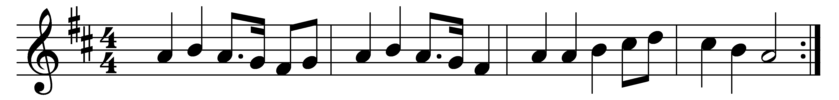

Lord, dismiss us with thy blessing;
fill our hearts with joy and peace;
let us each, thy love possessing,
triumph in redeeming grace:
O refresh us, O refresh us,
traveling through this wilderness.

Thanks we give and adoration
for thy Gospel’s joyful sound:
may the fruits of thy salvation
in our hearts and lives abound:
ever faithful, ever faithful
to thy truth may we be found;

so that when thy love shall call us,
Savior, from the world away,
fear of death shall not appall us,
glad thy summons to obey.
May we ever, may we ever
reign with thee in endless day.

Words: Attributed to John Fawcett (1739/40-1817)
Music: Sicilian melody, first published in The European Magazine and London Review, 1792

