Shepherd of souls, refresh and bless Hymnal 1982 no. 343 Melody: St Agnes C.M.
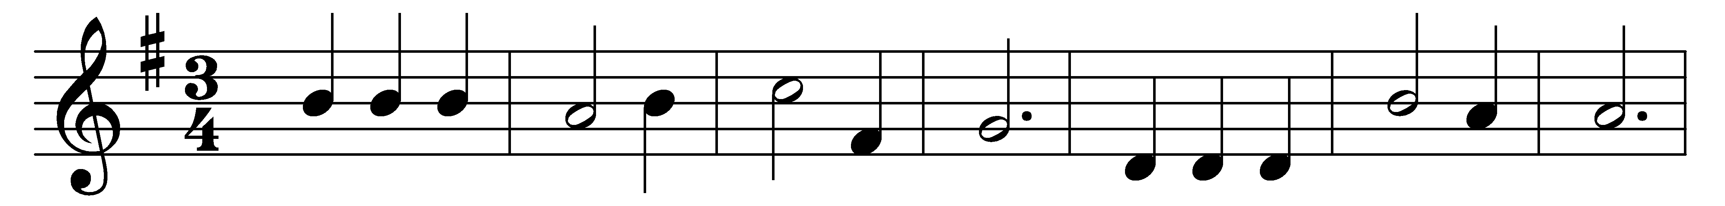

Shepherd of souls, refresh and bless
thy chosen pilgrim flock
with manna in the wilderness,
with water from the rock.

We would not live by bread alone,
but by thy word of grace,
in strength of which we travel on
to our abiding-place.

Be known to us in breaking bread,
and do not then depart;
Savior, abide with us, and spread
thy table in our heart.

Lord, sup with us in love divine,
thy Body and thy Blood,
that living bread, that heavenly wine,
be our immortal food.

Words: James Montgomery (1771-1854)
Music: John Bacchus Dykes (1823-1876)

