Wherefore, O Father, we thy humble servants Hymnal 1982 no. 338
Melody: Lobet den Herren 11 11. 11. 5.
Words from AMNS
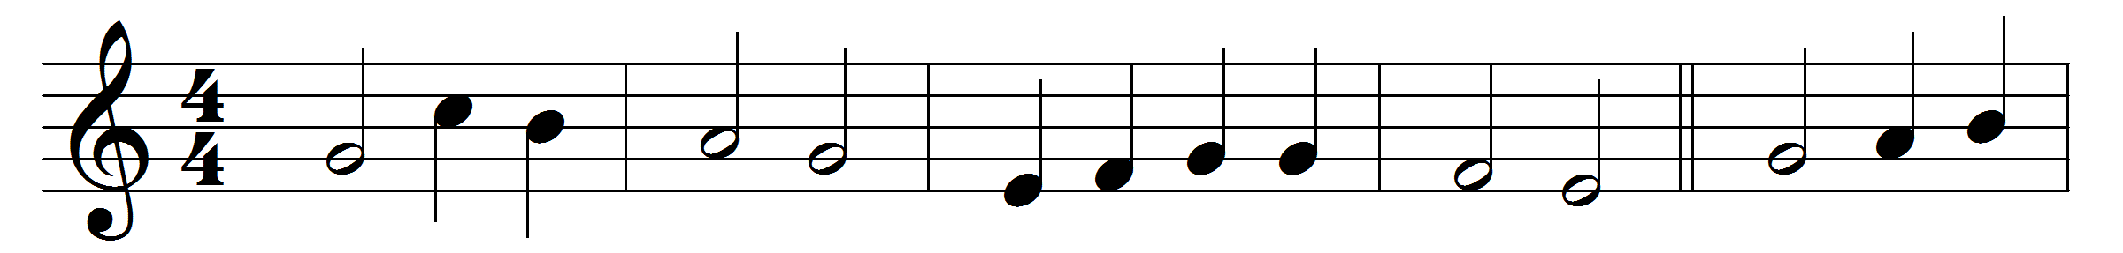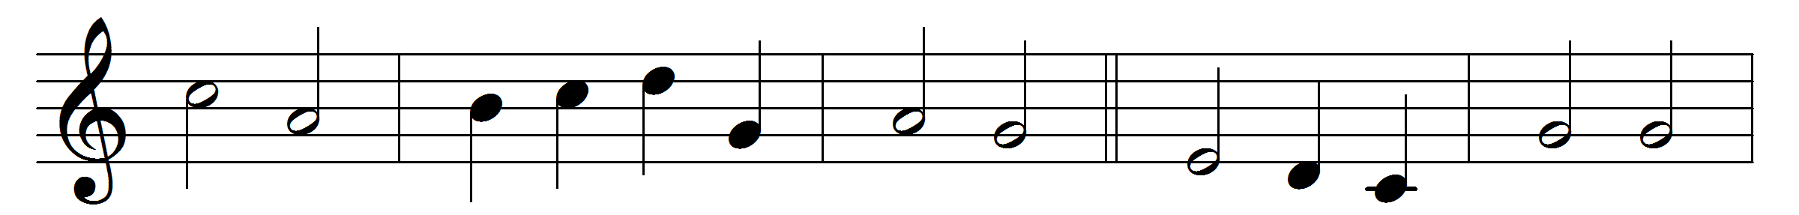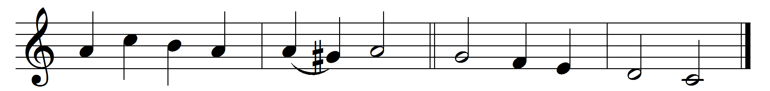

Wherefore, O Father, we thy humble servants
here bring before thee Christ thy well-belovèd,
all perfect offering, sacrifice immortal,
spotless oblation.

See now thy children, making intercession
through him our Saviour, Son of God incarnate,
for all thy people, living and departed,
pleading before thee.

Words: William Henry Hammond Jervois (1852-1905)
Music: Melody by Johann Crüger (1598-1662), harmony by Friedrich Layriz (1808-1859)

