Draw nigh and take the Body of the Lord Hymnal 1982 no. 328 Melody: Song 46 10. 10.

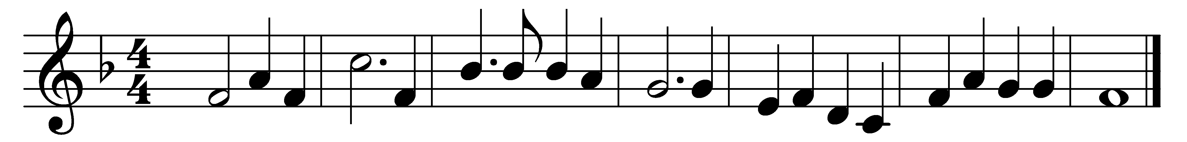

Draw nigh and take the Body of the Lord,
and drink the holy Blood for you outpoured.

Saved by that Body and that holy Blood,
with souls refreshed, we render thanks to God.

Salvation’s giver, Christ, the only Son,
by his dear cross and blood the victory won.

Offered was he for greatest and for least,
himself the Victim, and himself the Priest.

Approach ye then with faithful hearts sincere,
and take the pledges of salvation here.

He that his saints in this world rules and shields
to all believers life eternal yields;

with heavenly bread he makes the hungry whole,
gives living waters to the thirsting soul.

Alpha-Omega, unto whom shall bow
all nations at the doom, is with us now.

Words: Bangor Antiphoner, c. 690, translated by John Mason Neale (1818-1866)
Music: Melody and bass by Orlando Gibbons (1583-1625), harmony from The English Hymnal, 1906

