Let thy Blood in mercy poured Hymnal 1982 no. 313
Melody: Jesus, meine Zuversicht 7 8. 7 8. 7 7.
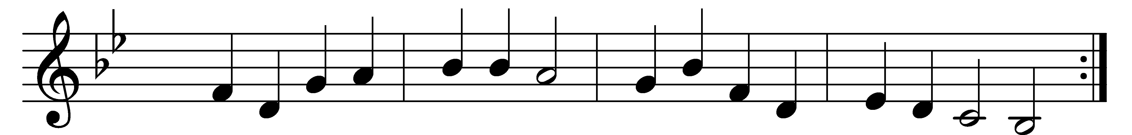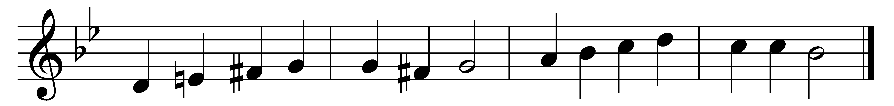

Let thy Blood in mercy poured,
let thy gracious Body broken,
be to me, O gracious Lord,
of thy boundless love the token.
(Refrain:) Thou didst give thyself for me,
now I give myself to thee.

Thou didst die that I might live;
blessèd Lord, thou cam’st to save me;
all that love of God could give
Jesus by his sorrows gave me. (Refrain)

By the thorns that crowned thy brow,
by the spear-wound and the nailing,
by the pain and death, I now
claim, O Christ, thy love unfailing. (Refrain)

Wilt thou own the gift I bring?
All my penitence I give thee;
thou art my exalted King,
of thy matchless love forgive me. (Refrain)

Words: John Brownlie (1859-1925)
Music: Melody by Johann Crüger (1598-1662), harmony based on The Chorale Book for England, 1863

